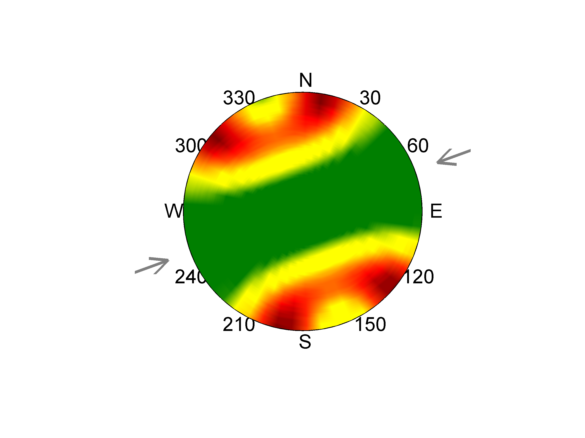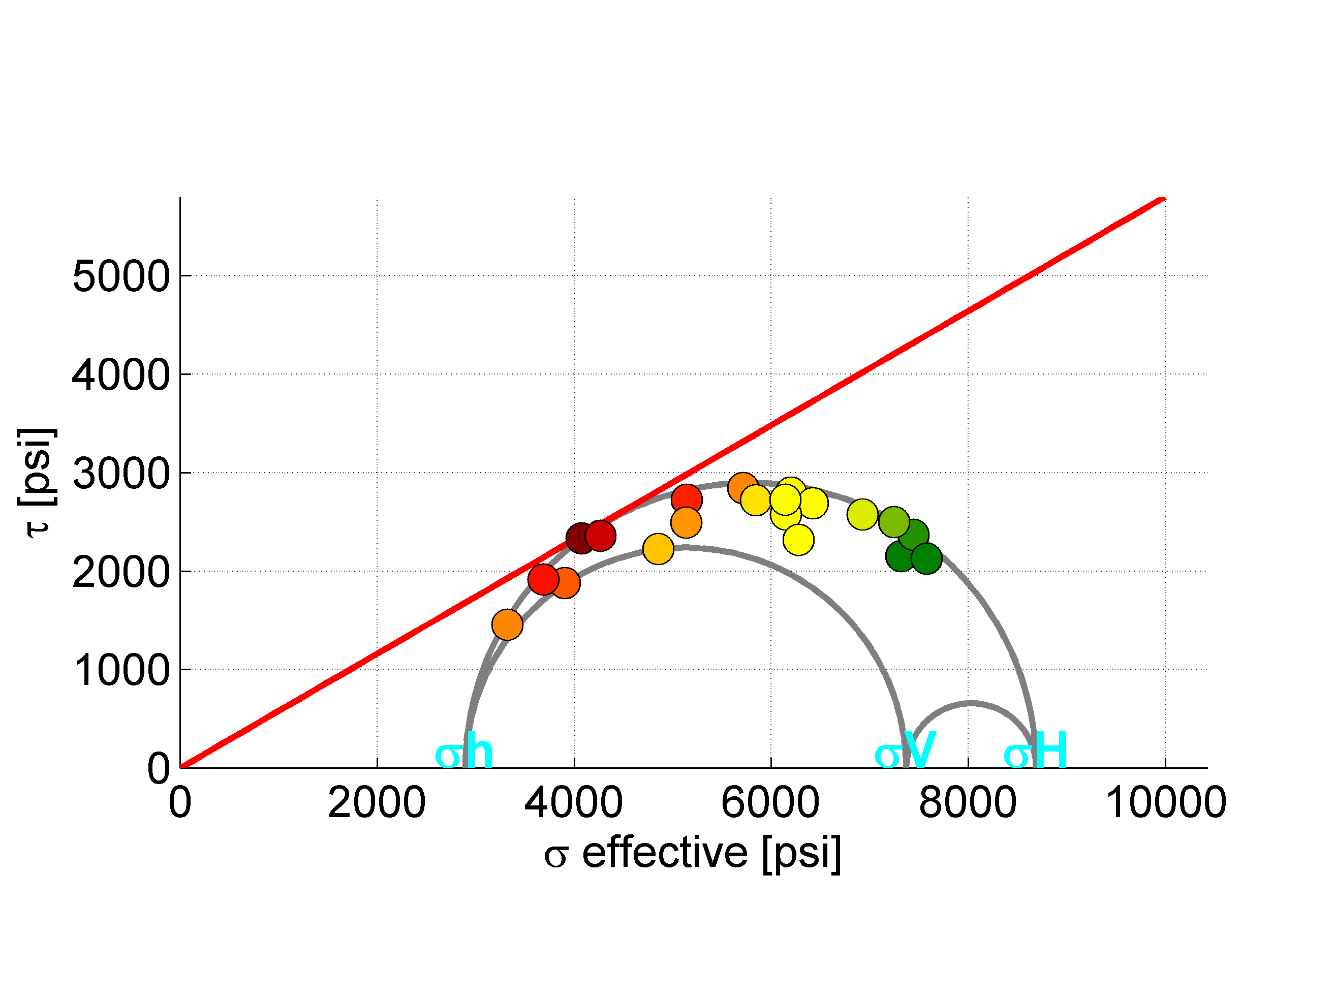

FSP 2.0: A Program for Probabilistic Estimation of Fault Slip Potential Resulting From Fluid Injection

A tool for probabilistically screening faults near injection wells from the Stanford Center for Induced and Triggered Seismicity, developed through industry-academic collaboration

By Rall Walsh III1, Mark D. Zoback1*, Suvrat P. Lele2, Darren Pais2, Matthew Weingarten1, and Timothy Tyrrell3

1 Department of Geophysics, Stanford University, 397 Panama Mall, Stanford, CA 94305

2 ExxonMobil Upstream Research Company, 22777 Springwoods Village Parkway,

Spring, TX 77389

3 XTO Energy, 22777 Springwoods Village Parkway, Spring, TX 77389

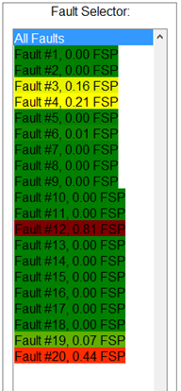*FaultSlipPotential@gmail.com,

Free at SCITS.stanford.edu/software, March 2, 2017

Modified November 2018

© Copyright 2016-2018, the author(s), all rights reserved.

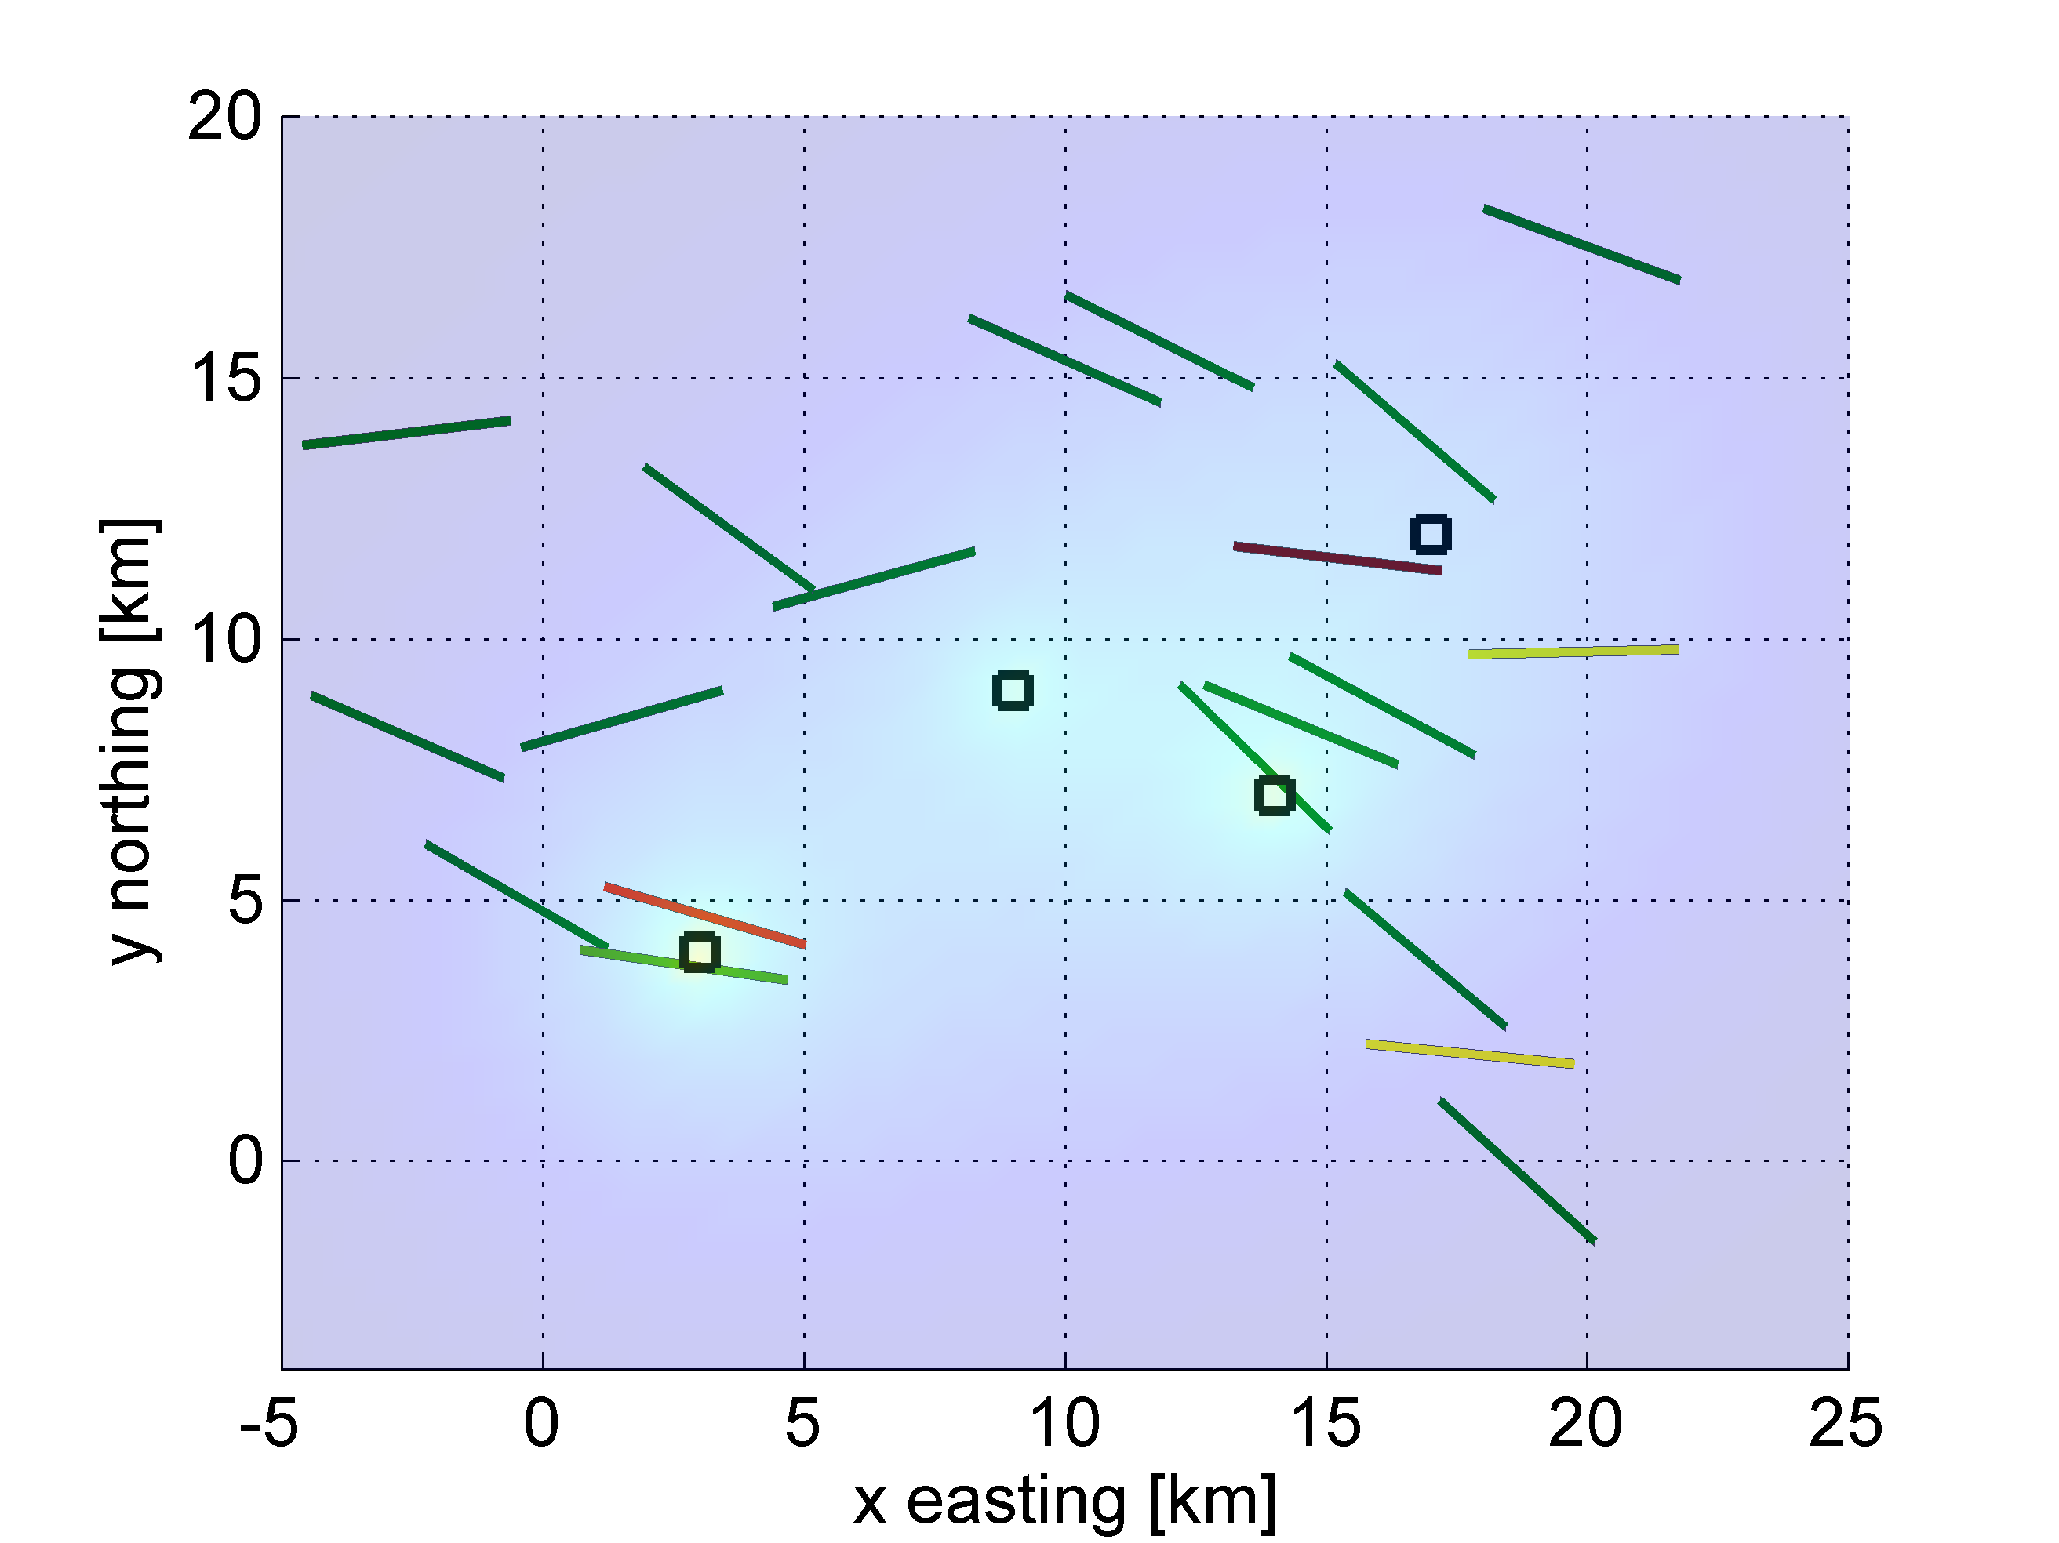

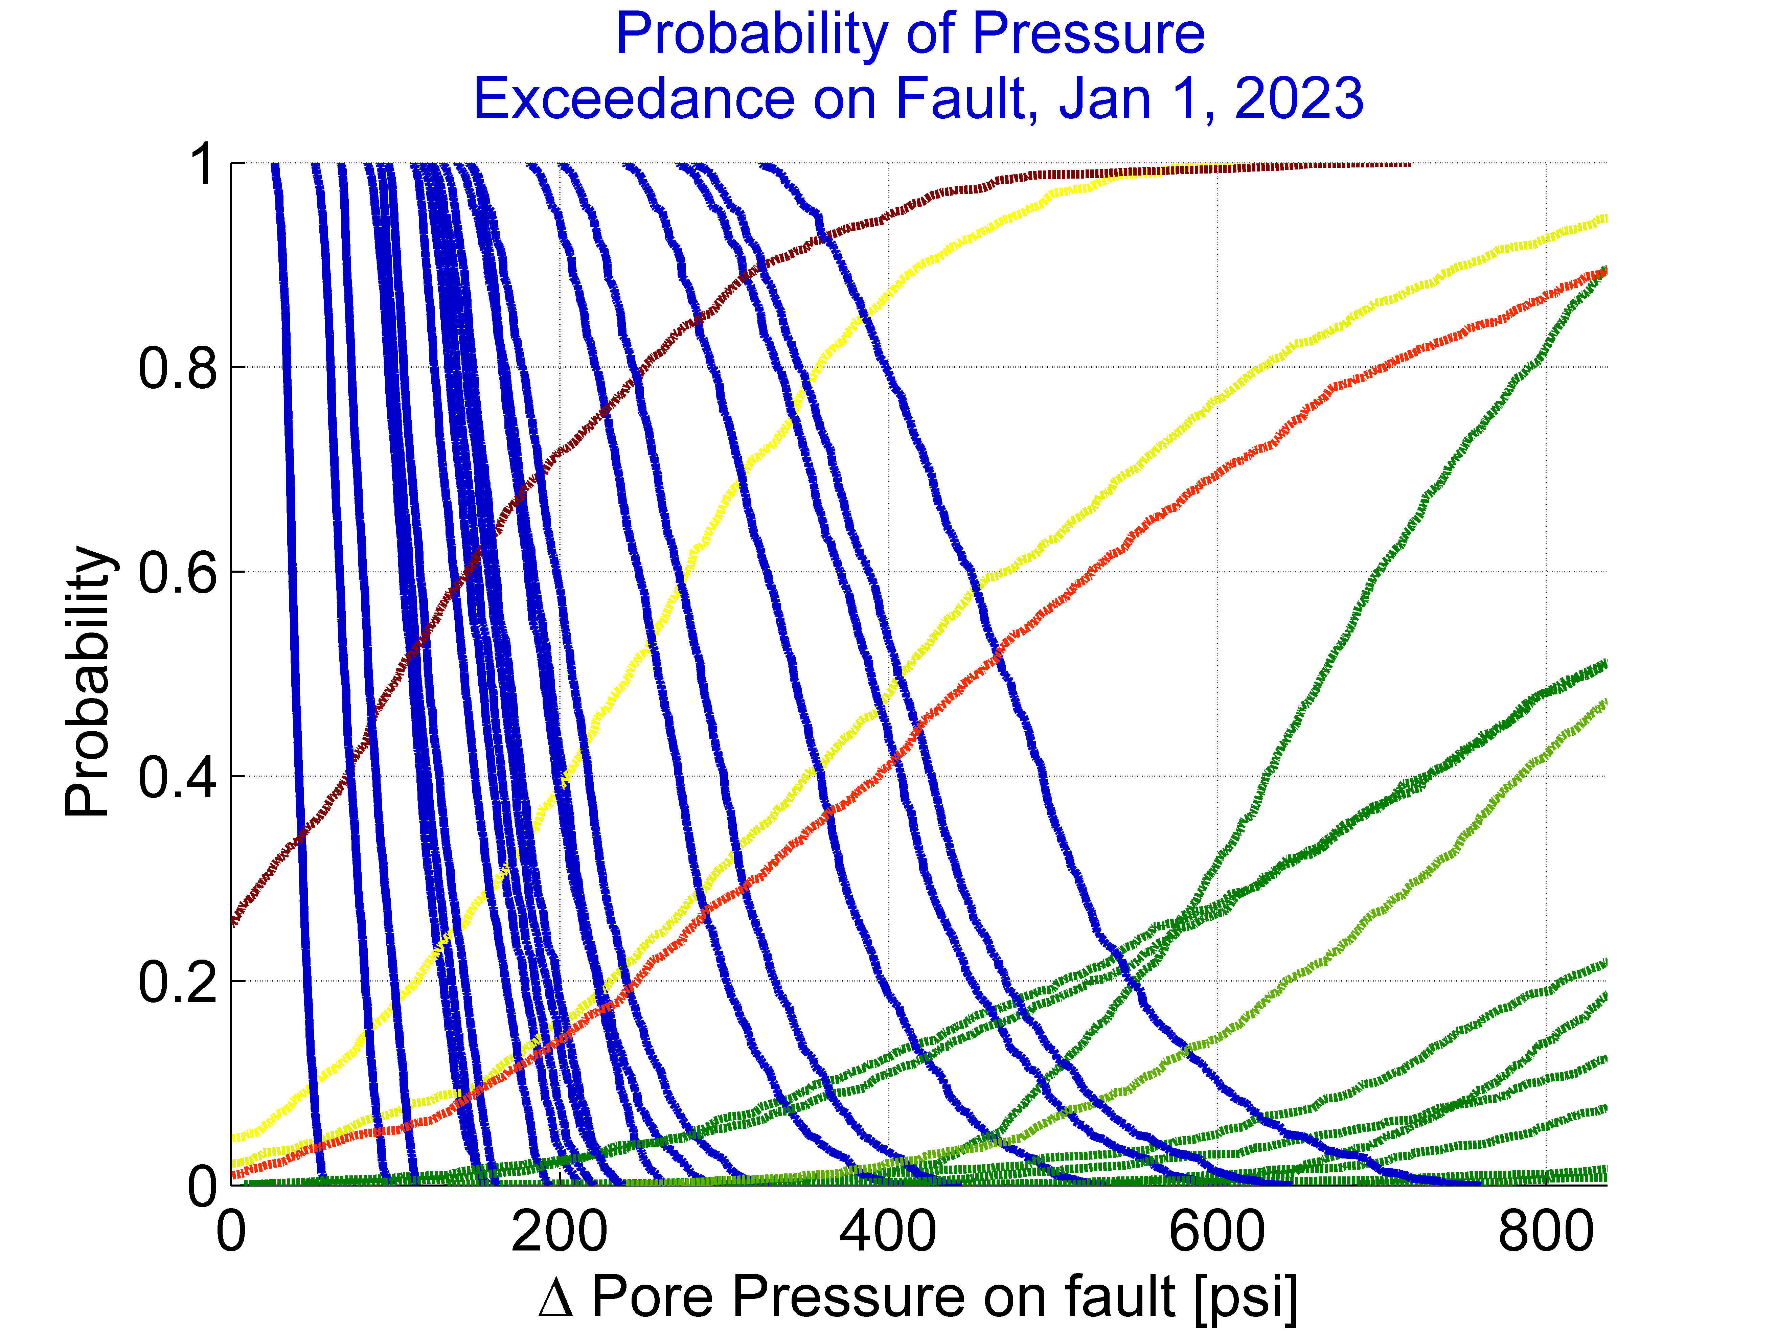

# LICENSE

The source code associated with this downloadable file is a derivative work based in part on supplements to, and modifications of, a Matlab-based script originally developed by ExxonMobil Upstream Research Company.  To enable broader software distribution ExxonMobil Upstream Research Company provides the opportunity to license under the open-source framework provided by The Apache Software Foundation.  As of January 1, 2017, The Apache Software Foundation is a US-based membership corporation and an 501(c)(3) non-profit foundation.

Copyright 2016 ExxonMobil Upstream Research Company

Licensed under the Apache License, Version 2.0 (the "License"); you may not use this file except in compliance with the License. You may obtain a copy of the License at

<http://www.apache.org/licenses/LICENSE-2.0>.

Unless required by applicable law or agreed to in writing, software distributed under the

License is distributed on an "AS IS" BASIS, WITHOUT WARRANTIES OR CONDITIONS OF ANY KIND, either express or implied. See the License for the specific language governing permissions and limitations under the License.

Copyright (c) 2016, Stanford University,

All rights reserved.

Redistribution and use in binary form, with or without modification, is permitted provided that the following conditions are met:

* Redistributions of code must retain the above copyright notice and license, this list of conditions and the following disclaimer.

* Redistributions in binary form must reproduce the above copyright notice, this list of conditions and the following disclaimer in the documentation and/or other materials provided with the distribution.

* Neither the name of Stanford University, nor the name of the Stanford Center for Induced and Triggered Seismicity, nor the names of contributors may be used to endorse or promote products derived from this software without specific prior written permission.

* If the software is used to develop scientific or technical material that is published in any peer-reviewed papers, conference abstracts or similar publications, the recipient agrees to acknowledge the Stanford Center for Induced and Triggered Seismicity in a manner consistent with industry practice, such as the one outlined in the Suggested Citation section.

* Code is provided without support.

* The author(s) would appreciate being notified of any errors found in the supplied program by emailing: FaultSlipPotential+bugs@gmail.com

THIS SOFTWARE IS PROVIDED BY THE COPYRIGHT HOLDERS AND CONTRIBUTORS "AS IS" AND ANY EXPRESS OR IMPLIED WARRANTIES, INCLUDING, BUT NOT LIMITED TO, THE IMPLIED WARRANTIES OF MERCHANTABILITY AND FITNESS FOR A PARTICULAR PURPOSE ARE DISCLAIMED. IN NO EVENT SHALL THE COPYRIGHT OWNER OR CONTRIBUTORS BE LIABLE FOR ANY DIRECT, INDIRECT, INCIDENTAL, SPECIAL, EXEMPLARY, OR CONSEQUENTIAL DAMAGES (INCLUDING, BUT NOT LIMITED TO, PROCUREMENT OF SUBSTITUTE GOODS OR SERVICES; LOSS OF USE, DATA, OR PROFITS; MISCALCULATION OF FAULT SLIP POTENTIAL; BUSINESS LIABILITY OR BUSINESS INTERRUPTION) HOWEVER CAUSED AND ON ANY THEORY OF LIABILITY, WHETHER IN CONTRACT, STRICT LIABILITY, OR TORT (INCLUDING NEGLIGENCE OR OTHERWISE) ARISING IN ANY WAY OUT OF THE USE OF THIS SOFTWARE, EVEN IF ADVISED OF THE POSSIBILITY OF SUCH DAMAGE.

ABSTRACT

Fault Slip Potential (FSP) tool provides a methodology for calculating the cumulative probability of a known fault exceeding Mohr-Coulomb slip criteria from fluid injection. The graphical user interface of the tool is based on the concepts of quantitative risk assessment applied to hydrology and geomechanics, and accepts the following input parameters: fault strike and dip, well locations and injection rates, hydrologic parameters and mechanical stress state parameters. Faults can be randomly generated or imported. The methodology works as follows: first, the Mohr-Coulomb pore pressure to slip on each fault is calculated using a deterministic approach. Next, a Monte-Carlo analysis of the same parameter is run on each fault, which yields the probability of each fault slipping as a function of pore pressure increase on it. Next, a hydrology model is used to assess specific injection scenarios and relate injection to pore pressure changes. The code provides a simple radial flow based model for pressure changes due to injection; pressure results exported from more complex reservoir models can be imported if desired. The output of the hydrologic model is used as the pore pressure input to the probabilistic fault slip model, which yields an estimate of the cumulative probability of the fault slipping as a function of time. The Monte-Carlo approach to uncertainty can optionally also be applied to the included hydrology model to calculate probability of pressure increase on each fault. The program is freely available through scits.stanford.edu/software.

**CHANGES IN VERSION 2.0:**

* Adds “Modified A-Phi” stress model that accepts the minimum horizontal stress, if available, as additional input to improve stress state model
* Simplified user interface for stress and fault data inputs
* Pressures to slip values less than zero (indicating fault already slipping) are reported as zero pressure to slip
* Bug fixes related to importing pressure changes from external hydrology model

TABLE OF CONTENTS

LICENSE 2

ABSTRACT 4

INTRODUCTION 7

Mechanisms of Induced Seismicity 7

The Quantitative Risk Assessment Approach 8

Modeling Approach, Assumptions and Limitations 9

WHAT FSP DOES: 13

Model Inputs Tab 13

Deterministic Geomechanics Tab 15

Tab Overview 15

Details 15

Using the Tab 15

Probabilistic Geomechanics Tab 17

Tab Overview 17

Using the Tab 17

Sensitivity Analysis 19

Deterministic Hydrology Tab 21

Tab Overview 21

Using the Tab 21

Probabilistic Hydrology Tab 23

Tab Overview 23

Using Deterministic Hydrology to Calculate Slip Potential 24

Using Probabilistic Hydrology to Calculate Slip Potential 25

Integrated Tab: Summarizing Results 28

Tab Overview 28

Using the Tab 28

User Interface Menus 32

File Menu 32

Data Inputs Menu 32

Stress Data 33

Hydrology Data 35

Injection Well Data 37

Fault Data 38

Advanced Parameters 40

Exporting High Resolution Images Menu 41

Zoom Menu 42

Data Cursor 42

Fault Selector Menu 43

DISCUSSION 44

PROGRAM INSTALLATION 44

REFERENCES AND RELATED PAPERS 45

APPENDIX A: SELECTED SCREENSHOTS 47

INTRODUCTION

Despite the importance of induced seismicity, few tools are currently available to help operators and regulators make informed decisions when designing injection operations. Of particular use to decision-makers would be the ability to quantitatively predict which faults might have some probability of slip under a given injection scenario. Here, we aim to address this need by presenting a workflow and associated program for estimating the potential for induced fault slip within in the context of operational uncertainty.

## Mechanisms of Induced Seismicity

A variety of human activities can result in induced fault slip. These include conventional oil and gas production, hydraulic fracturing, enhanced oil recovery, geothermal production, fluid injection, mining, and dam impoundment. The physical mechanisms by which these activities can induce seismicity also vary widely, and include stress tensor perturbations, decreases in effective stress associated with changes in pore pressure, reservoir inflation or deflation, differential compaction, and a variety of poroelastic, thermoelastic, and chemical effects (Figure 1 illustrates some of these mechanisms). Earthquakes also occur naturally, and can trigger each other through both dynamic and static mechanisms. In this model, which we call Fault Slip Potential (FSP), we focus on induced seismicity associated with water injection by quantifying the potential for pressurization of pore fluids inducing fault slip via Mohr-Coulomb unclamping: the decrease in effective normal stress resulting from an increase in pore pressure. While the focus on only one mechanism is arguably a limitation of the program, especially because other mechanisms are likely applicable in some cases, we argue in chapters 2 and 3 that it is the most relevant mechanism.

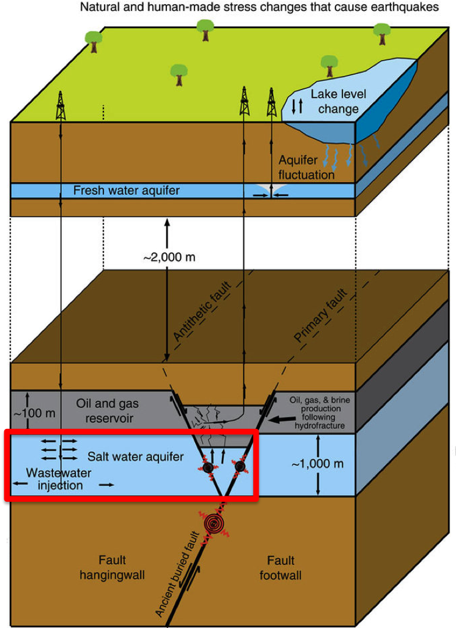

**Figure 1** There are many possible mechanisms by which slip on an existing fault can be triggered. The Fault Slip Potential program (FSP) evaluates the potential for fault slip to be induced by fluid injection in the vicinity of known faults at depth (highlighted in red box). Figure modified with permission from Hornbach et al. 2015.

## The Quantitative Risk Assessment Approach

In the context of Coulomb faulting theory, whether or not a fault will slip in response to fluid injection depends on several factors, including the magnitude and orientation of the stress field, the orientation of the fault, the pore pressure, and material parameters such as the coefficient of friction. Because there is uncertainty in each of these parameters, we use Quantitative Risk Assessment (QRA) to evaluate the possibility that each of the mapped faults might slip in response to a given pore pressure increase. QRA is a Monte Carlo method used to evaluate the probability of an uncertain outcome when the input parameters themselves are uncertain. In QRA, uncertainties in input parameters are propagated through the model by iteratively running the model using inputs randomly sampled from input probability density functions (PDFs) and aggregating the distribution of results. In the case of FSP, the output is a Cumulative Distribution Function (CDF) describing the cumulative probability of fault slip as a function of pore pressure added to the fault.

QRA has been used in a wide variety of operational decisions and has an extensive history of use in the field of applied rock mechanics. It has been used to evaluate wellbore stability (Moos et al., 2003) and fault seal (Jones and Hillis, 2003). In a 2015 study, Chae and Lee used QRA to investigate leakage of CO2 from carbon sequestration reservoirs through wells, faults, and fractured cap rocks. Chiaramonte et al. (2007) used QRA to investigate whether increases in pore pressure from a CO2 injection pilot project could induce fault slip.

Here we extend the work of Walsh and Zoback (2016), who generalized QRA to study potential slip on mapped faults of uncertain orientation under uncertain stress conditions. The 2016 model assumed a constant deterministic pressure increase on each fault regardless of location. In this work, we build on the 2016 model by incorporating a hydrological model relating injection rates to changes in pore pressure. The addition of a hydrologic model allows us to study the effects of injection rates on potential induced seismicity directly. This program is also generic so that it may be applied anywhere data is available.

FSP allows the user to run two versions of the hydrologic model: a deterministic version, which calculates a single pressure increase on each fault, and a probabilistic version, which applies the QRA approach to the hydrologic model. This second approach involves sampling the PDFs of input hydrologic parameters, including porosity and permeability, to produce a distribution of possible pore pressures on each fault. The deterministic approach is computationally faster, making it ideal for models with many wells with varying injection rates injecting over many years. In contrast, the QRA (probabilistic) approach is ideal for simpler hydrologic models with fewer wells, fewer months of injection, or constant injection rates. See the “Probabilistic Hydrology” section below for more details on this alternative.

## Modeling Approach, Assumptions and Limitations

Before delving into the details of the model, it is important to note some key limitations. FSP is designed not only to help a user understand of the probability of injection-induced seismicity via this mechanism, but also for ease of operation and practicality - it aims to take the smallest number of input parameters possible while still being useful.

The geomechanical analysis to calculate pore pressure increase leading to fault slip is based on the most prevalent injection induced seismicity scenario, such as in Oklahoma, where injection in one layer leads to pressure increase in that layer; this higher pressure is transmitted along a permeable to fault gouge zone to basement layer below, resulting seismicity in the basement layer, as shown in Figure 1. Pore pressure increase in the injection layer leads to changes in vertical and horizontal stresses in that layer. However, for low permeability basement layer, the pressure changes occur primarily in the fault gouge zone and effective stress changes in other regions are negligible. The pressure increase in fault gouge zone reduces effective normal stress in the fault plane, which makes slip more likely.



**Figure 2** Slip in basement layer due to pressure transmission along permeable fault gouge zone.

Mohr circle diagram based on vertical and horizontal stresses is plotted, and location of the stress state of each fault plane on this diagram is also indicated in FSP output. As pore pressure increases due to injection, the effective stresses decrease and the Mohr circles move to the left on the plot towards the frictional slip line (note that the same friction coefficient is used for all faults). Hence, the horizontal distance from fault stress state point to the frictional slip line indicates the pore pressure to slip for that fault, as seen in Figure 2. Note that this predicted pressure corresponds to the pressure to slip for the basement seismicity scenario; the pressure to slip in the injection layer itself is generally higher (for normal and strike-slip faulting regimes) due to effective stress changes in that layer leading to changes in sizes of Mohr circle due to Poisson’s ratio effect. FSP focuses on the conservative (lower) pressure to slip estimate corresponding to slip in basement.



**Figure 3** Schematic Mohr circle diagram showing pressure to slip for a fault in near-critical orientation.

The hydrology calculation for pressure increase due to injection are based on analytical equation for radial flow in a uniform infinite layer bounded by impermeable confining layers on top and bottom (Hsieh and Bredehoeft, 1981):



and ** and *f* are density and dynamic viscocity of the fluid respectively, and g is the acceleration due to gravity. The pressure increases due to multiple wells are calculated by superimposing those due to each well. FSP allows importing pressure change results from an external reservoir simulator if a more complex hydrology model is necessary.

FSP performs a probabilistic Monte Carlo analysis based on user specified variability in the input paramters for both geomechanical and hydrology calculations. Note that probabilistic analysis for hydrology is only supported when internal radial flow based model is used and not when results from external reservoir simulator are imported. The combination of (i) probability of pressure increase by given amount leading to fault slip from probabilistic geomechanical analysis and (ii) probability of that amount of pressure increase from probabilistic hydrology calculation is used to determine the fault slip potential of the fault.

The overall FSP modeling approach doesn’t predict potential magnitude of any potentially induced earthquakes, as that may reflect an unknowable history of slip on the particular fault, though a user might use geologic reasoning to pay extra attention to larger faults, as large earthquakes require large faults. It should be noted that it is likely that the history of slip on a fault would likely influence the stress distribution along a fault that determines rupture extent, and that this is generally unknowable in practical applications. FSP doesn’t predict earthquakes, and it doesn’t address whether a fault might have already slipped in recent geologic history, releasing existing stress. FSP does not assess risk, which is defined within the earthquake engineering community to be the product of hazard, exposure, and vulnerability at a particular location, and is used to describe the probabilities of adverse consequences (Walsh and Zoback, 2016); instead, it assesses the cumulative conditional probability of Mohr-Coulomb criteria slip on known faults. Note that fault slip potential is also different from seismic hazard, because it does not consider a potential fault’s earthquake rupture magnitude, depth, or associated ground shaking. It also doesn’t consider rate and state properties or complex fault interactions. FSP doesn’t account for small scale or local variations in the stress field associated with past earthquake activity, details of lithologic variation, and elastic, thermal, and other parameters that are often unknowable.

Despite these limitations, FSP provides a forward looking probabilistic screening tool for known faults near injection operations. The “What FSP Does” section below uses a generic case to show how FSP works. Next, in the “Data Inputs Menu” section, we discuss how to enter your own data.

# WHAT FSP DOES:

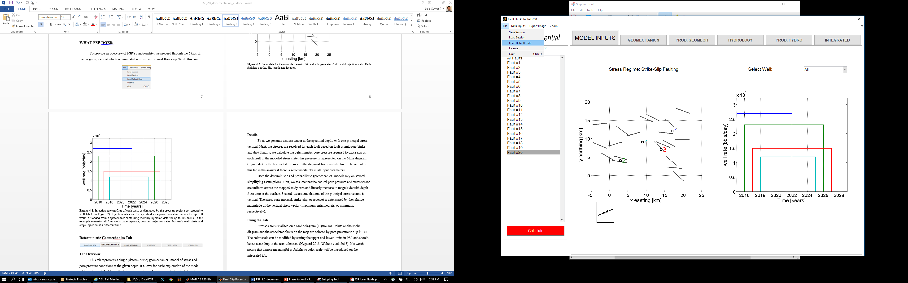

To provide an overview of FSP’s functionality, we proceed through the 6 tabs of the program, each of which is associated with a specific workflow step. To do this, we utilize a hypothetical injection scenario with 4 injection wells and 20 faults with random locations and orientations. This hypothetical case can be examined in the program by choosing “Load Default Data” under the file menu:

Pressing “yes” at the prompt loads the hypothetical case, runs the “Calculate” button, and opens the “Model Inputs” tab.

## Model Inputs Tab



The first step of the workflow is to constrain the model parameters. The “Model Inputs” tab allows the user to inspect data after it has been loaded. The required inputs will be described in more detail in the “Data Inputs Menu” section below. The inputs used for our example are displayed in Figure 4, a map of faults and injection wells, and Figure 5, which shows the well injection rates through time. Injection can be input as constant rates or loaded from a spreadsheet containing monthly injection volumes.

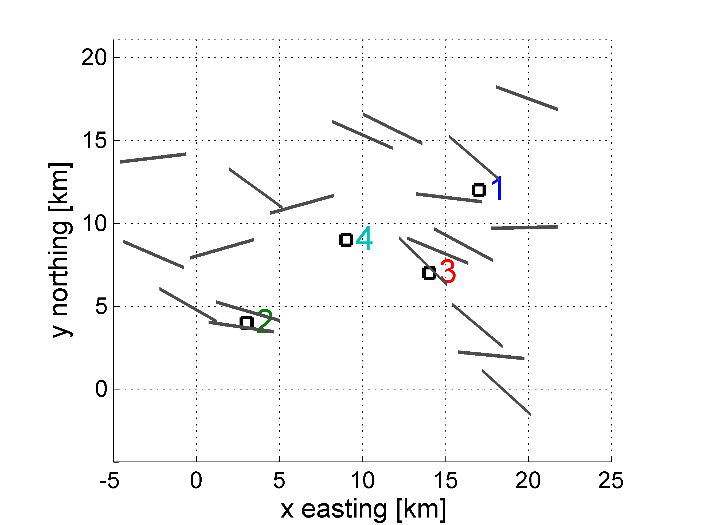

**Figure 4.** Input data for the example scenario: 20 randomly generated faults and 4 injection wells. Each fault has a strike, dip, length, and location.

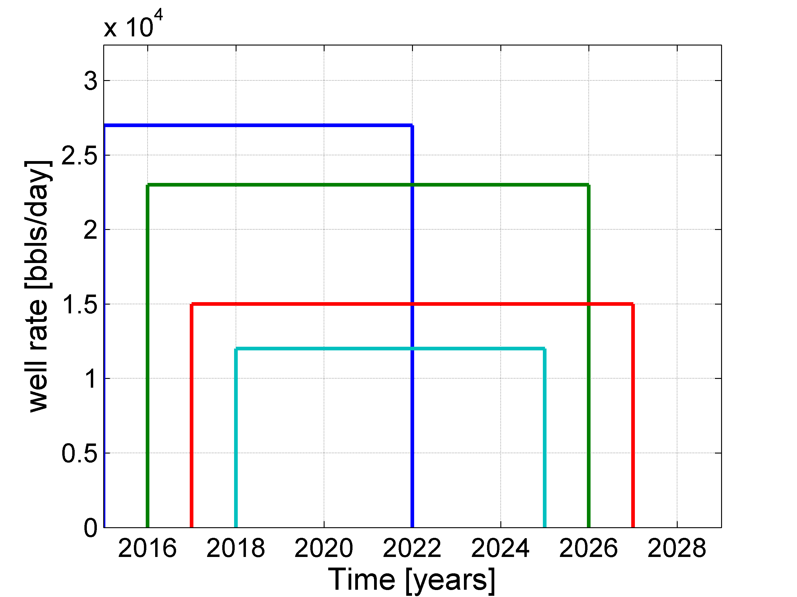

**Figure 5.** Injection rate profiles of each well, as displayed by the program (colors correspond to well labels in Figure 4). Injection rates can be specified as separate constant values for up to 8 wells, or loaded from a spreadsheet containing monthly injection data for up to 100 wells. In the example scenario, all four wells have separate, constant injection rates, but each well starts and stops injection at a different time.

## Deterministic Geomechanics Tab



### Tab Overview

This tab represents a single (deterministic) geomechanical model of stress and pore pressure conditions at the given depth. It allows for basic exploration of the model without the need for Monte Carlo iteration, and simulates a scenario in which there is no uncertainty in model parameters. In this tab, the pore pressure to slip is examined, but generally not reliable because the deterministic model ignores the large uncertainties often present in the relevant geomechanical parameters. In the next tab, we take a probabilistic approach and iterate the calculation to better understand the pore pressure to slip. The input parameters can be examined in the “Stress Data” and “Fault Data” tabs under the “Data inputs” menu.

### Details

First, we generate a stress tensor at the specified depth, with one principal stress vertical. Next, the stresses are resolved for each fault based on fault orientation (strike and dip). Finally, we calculate the deterministic pore pressure required to cause slip on each fault in the modeled stress state; this pressure is represented on the Mohr diagram (Figure 6a) by the horizontal distance to the diagonal frictional slip line. The output of this tab is the answer if there is zero uncertainty in all input parameters.

Both the deterministic and probabilistic geomechanical models rely on several simplifying assumptions. First, we assume that the natural pore pressure and stress tensor are uniform across the mapped study area and linearly increase in magnitude with depth from zero at the surface. Second, we assume that one of the principal stress vectors is vertical. The stress state (normal, strike-slip, or reverse) is determined by the relative magnitude of the vertical stress vector (maximum, intermediate, or minimum, respectively).

### Using the Tab

Stresses are visualized on a Mohr diagram (Figure 6a). Points on the Mohr diagram and the associated faults on the map are colored by pore pressure to slip in PSI. The color scale can be modified by setting the upper and lower limits in PSI, and should be set according to the user tolerance (Nygaard 2013, Walters et al. 2015). It’s worth noting that a more meaningful probabilistic color scale will be introduced on the integrated tab.

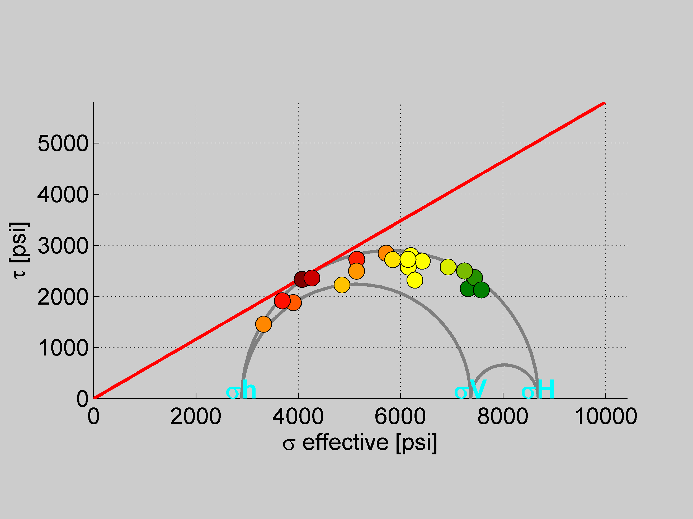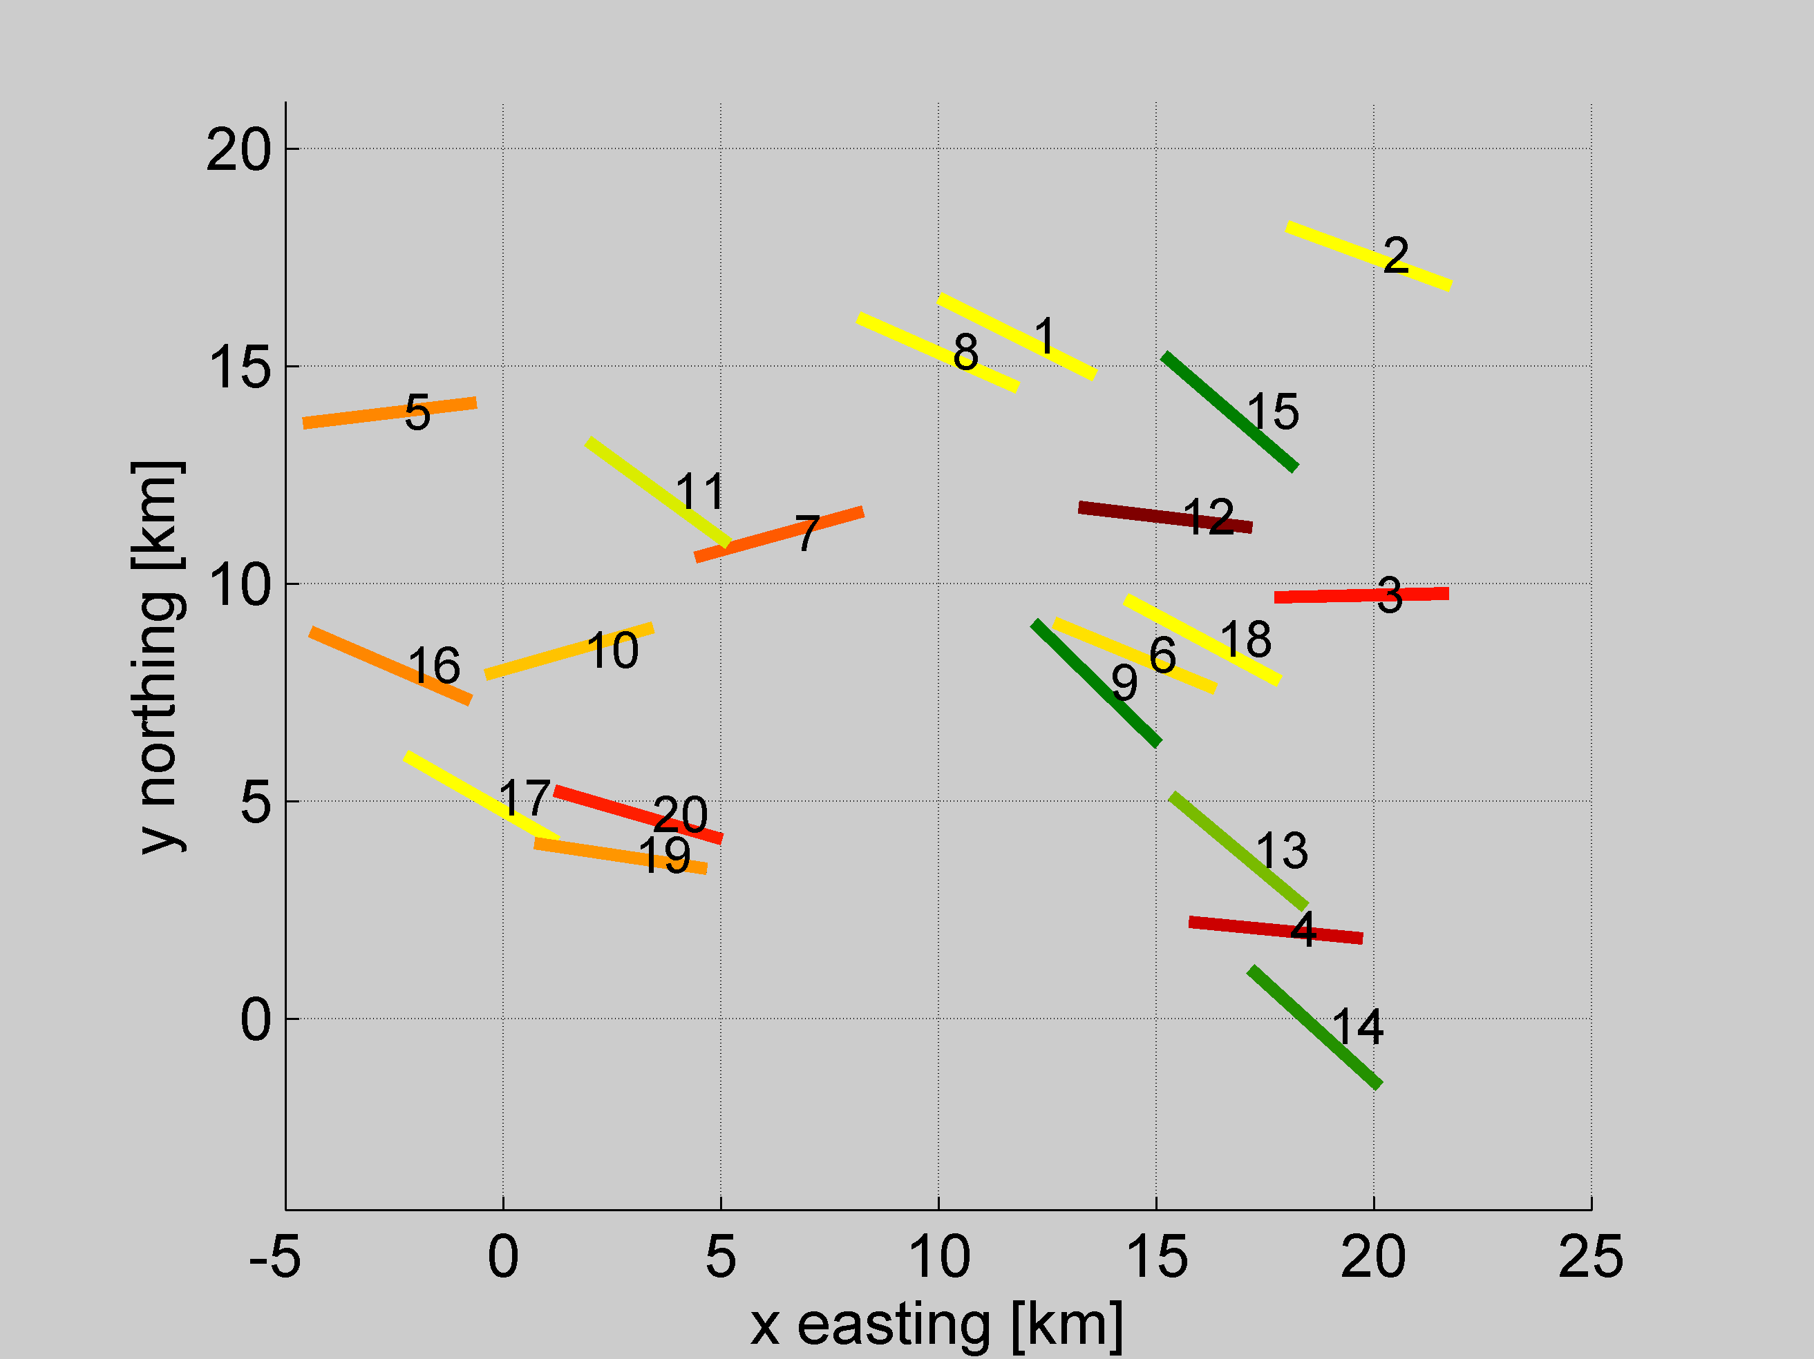

A.

C.

B.

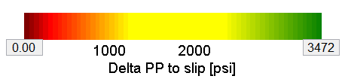

**Figure 6.** Results of a deterministic geomechanical assessment of fault pore pressure to slip: (A) faults shown on a Mohr diagram, with effective compressive stress on the horizontal axis and shear stress on the vertical axis. Principal stresses are labeled in cyan, and the frictional slip line is shown in red. Faults are colored by their horizontal distance to slip in PSI (according to the color scale); (B) the same faults mapped and colored by deterministic pore pressure to slip, labeled by their index number (C) the deterministic geomechanical color map, which can be edited manually.



B.

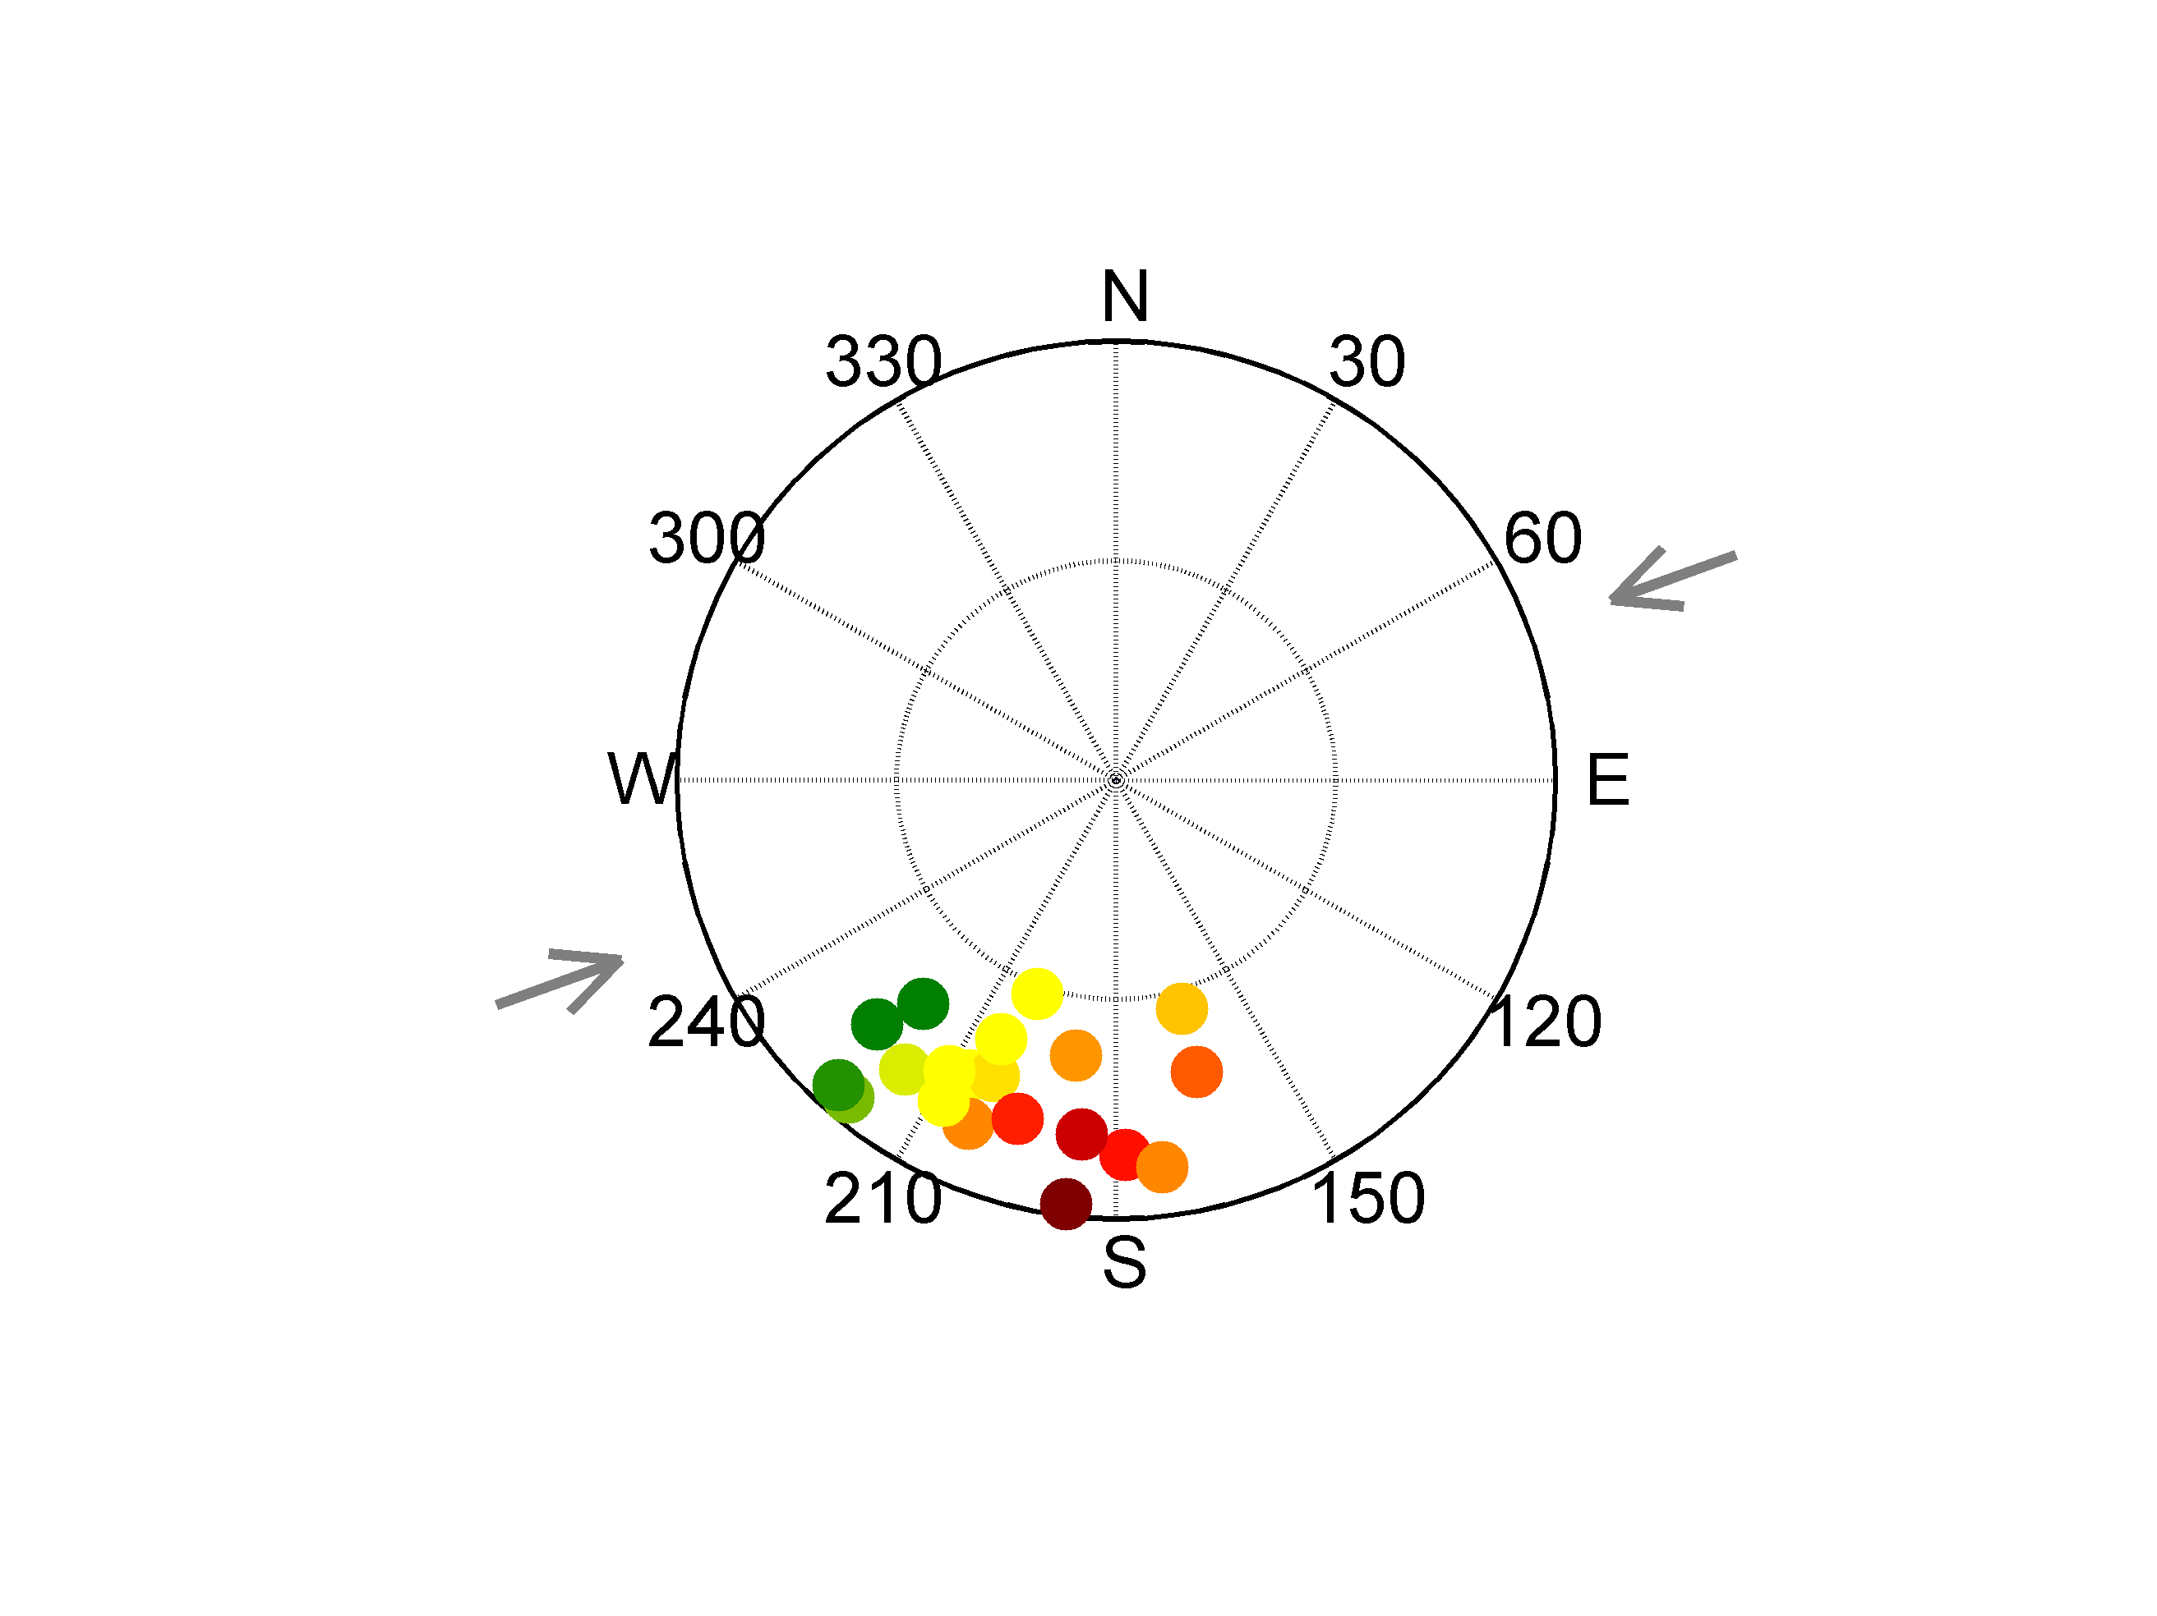

A.

**Figure 7.** (A) Fault normal orientations plotted on a lower hemisphere equal angle stereonet as dots. The azimuth of maximum horizontal compression is shown with grey arrows. (B) The composite stereonet colored at the corresponding faults’ normal orientation for all possible fault orientations based on the colormap chosen.

## Probabilistic Geomechanics Tab



### Tab Overview

The probabilistic geomechanics tab runs the same model as the deterministic geomechanics tab, except as a Monte Carlo simulation, which allows uncertainties in each parameter, described by a uniform probability distribution function, to be sampled randomly (Figure 8). A Monte Carlo approach is useful because it propagates the relevant uncertainties through the model, producing a distribution of pore pressures to slip.

### Using the Tab

Uncertainties in the relevant geomechanical parameters are entered using the 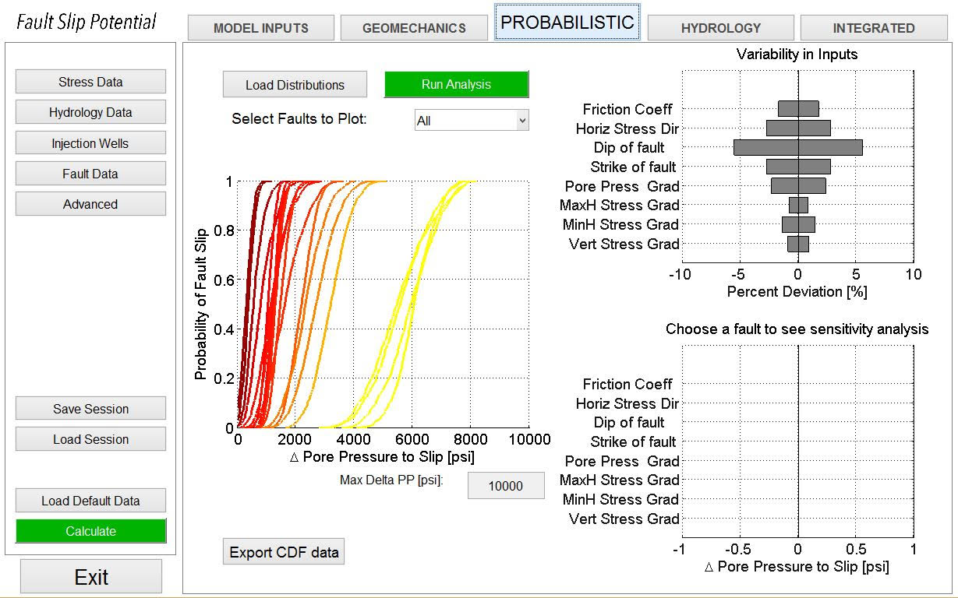 button of the probabilistic tab. In version 1.0, all parameters are given uniform distributions centered at the deterministic value previously entered. The +/- range of uncertainties can be set in the  menu, shown below.

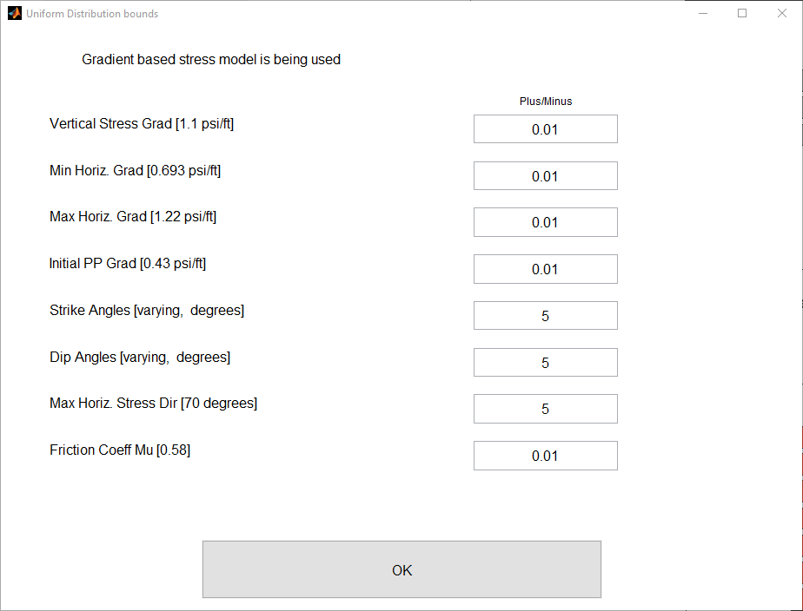

Example input distributions for the parameters in the above menu are shown in red in Figure 8. Histograms are generated when the operator presses the  button while a fault is selected. If multiple faults are selected, only the first one is used.

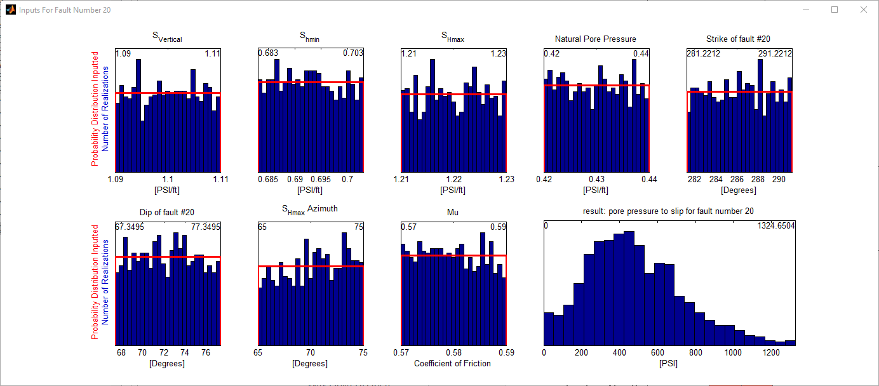

**Figure 8.** Histograms showing input parameter distributions for 1,000 geomechanical models that were generated by randomly sampling uniform distributions (shown in red) to evaluate the distribution of pressures required to slip on fault number 20. A histogram for distribution of predicted pore pressure to slip for the selected fault is also included.

The  button runs the geomechanics model through a Monte Carlo simulation, iterating the model randomly sampling the input probability distribution functions. The output is a cumulative distribution function (CDF) of the pore pressure to slip.

For a given fault, it is more useful to view the output as an empirical CDF than as a histogram because the conditional probability of fault slip is cumulative with increasing fluid pressure. Put another way, if pressure on a fault is increased by 100 PSI, pressure will pass each lower pressure (10 PSI, 20PSI, etc.) along the way. If the fault would slip at that lower pressure (say 20 PSI), it’s also of concern at the higher one(100 PSI). Thus, the CDF shows how the probability of fault slip evolves as the pore pressure increases. Figure 9 shows the CDF curve for each fault segment using the same color map as in Figure 6.

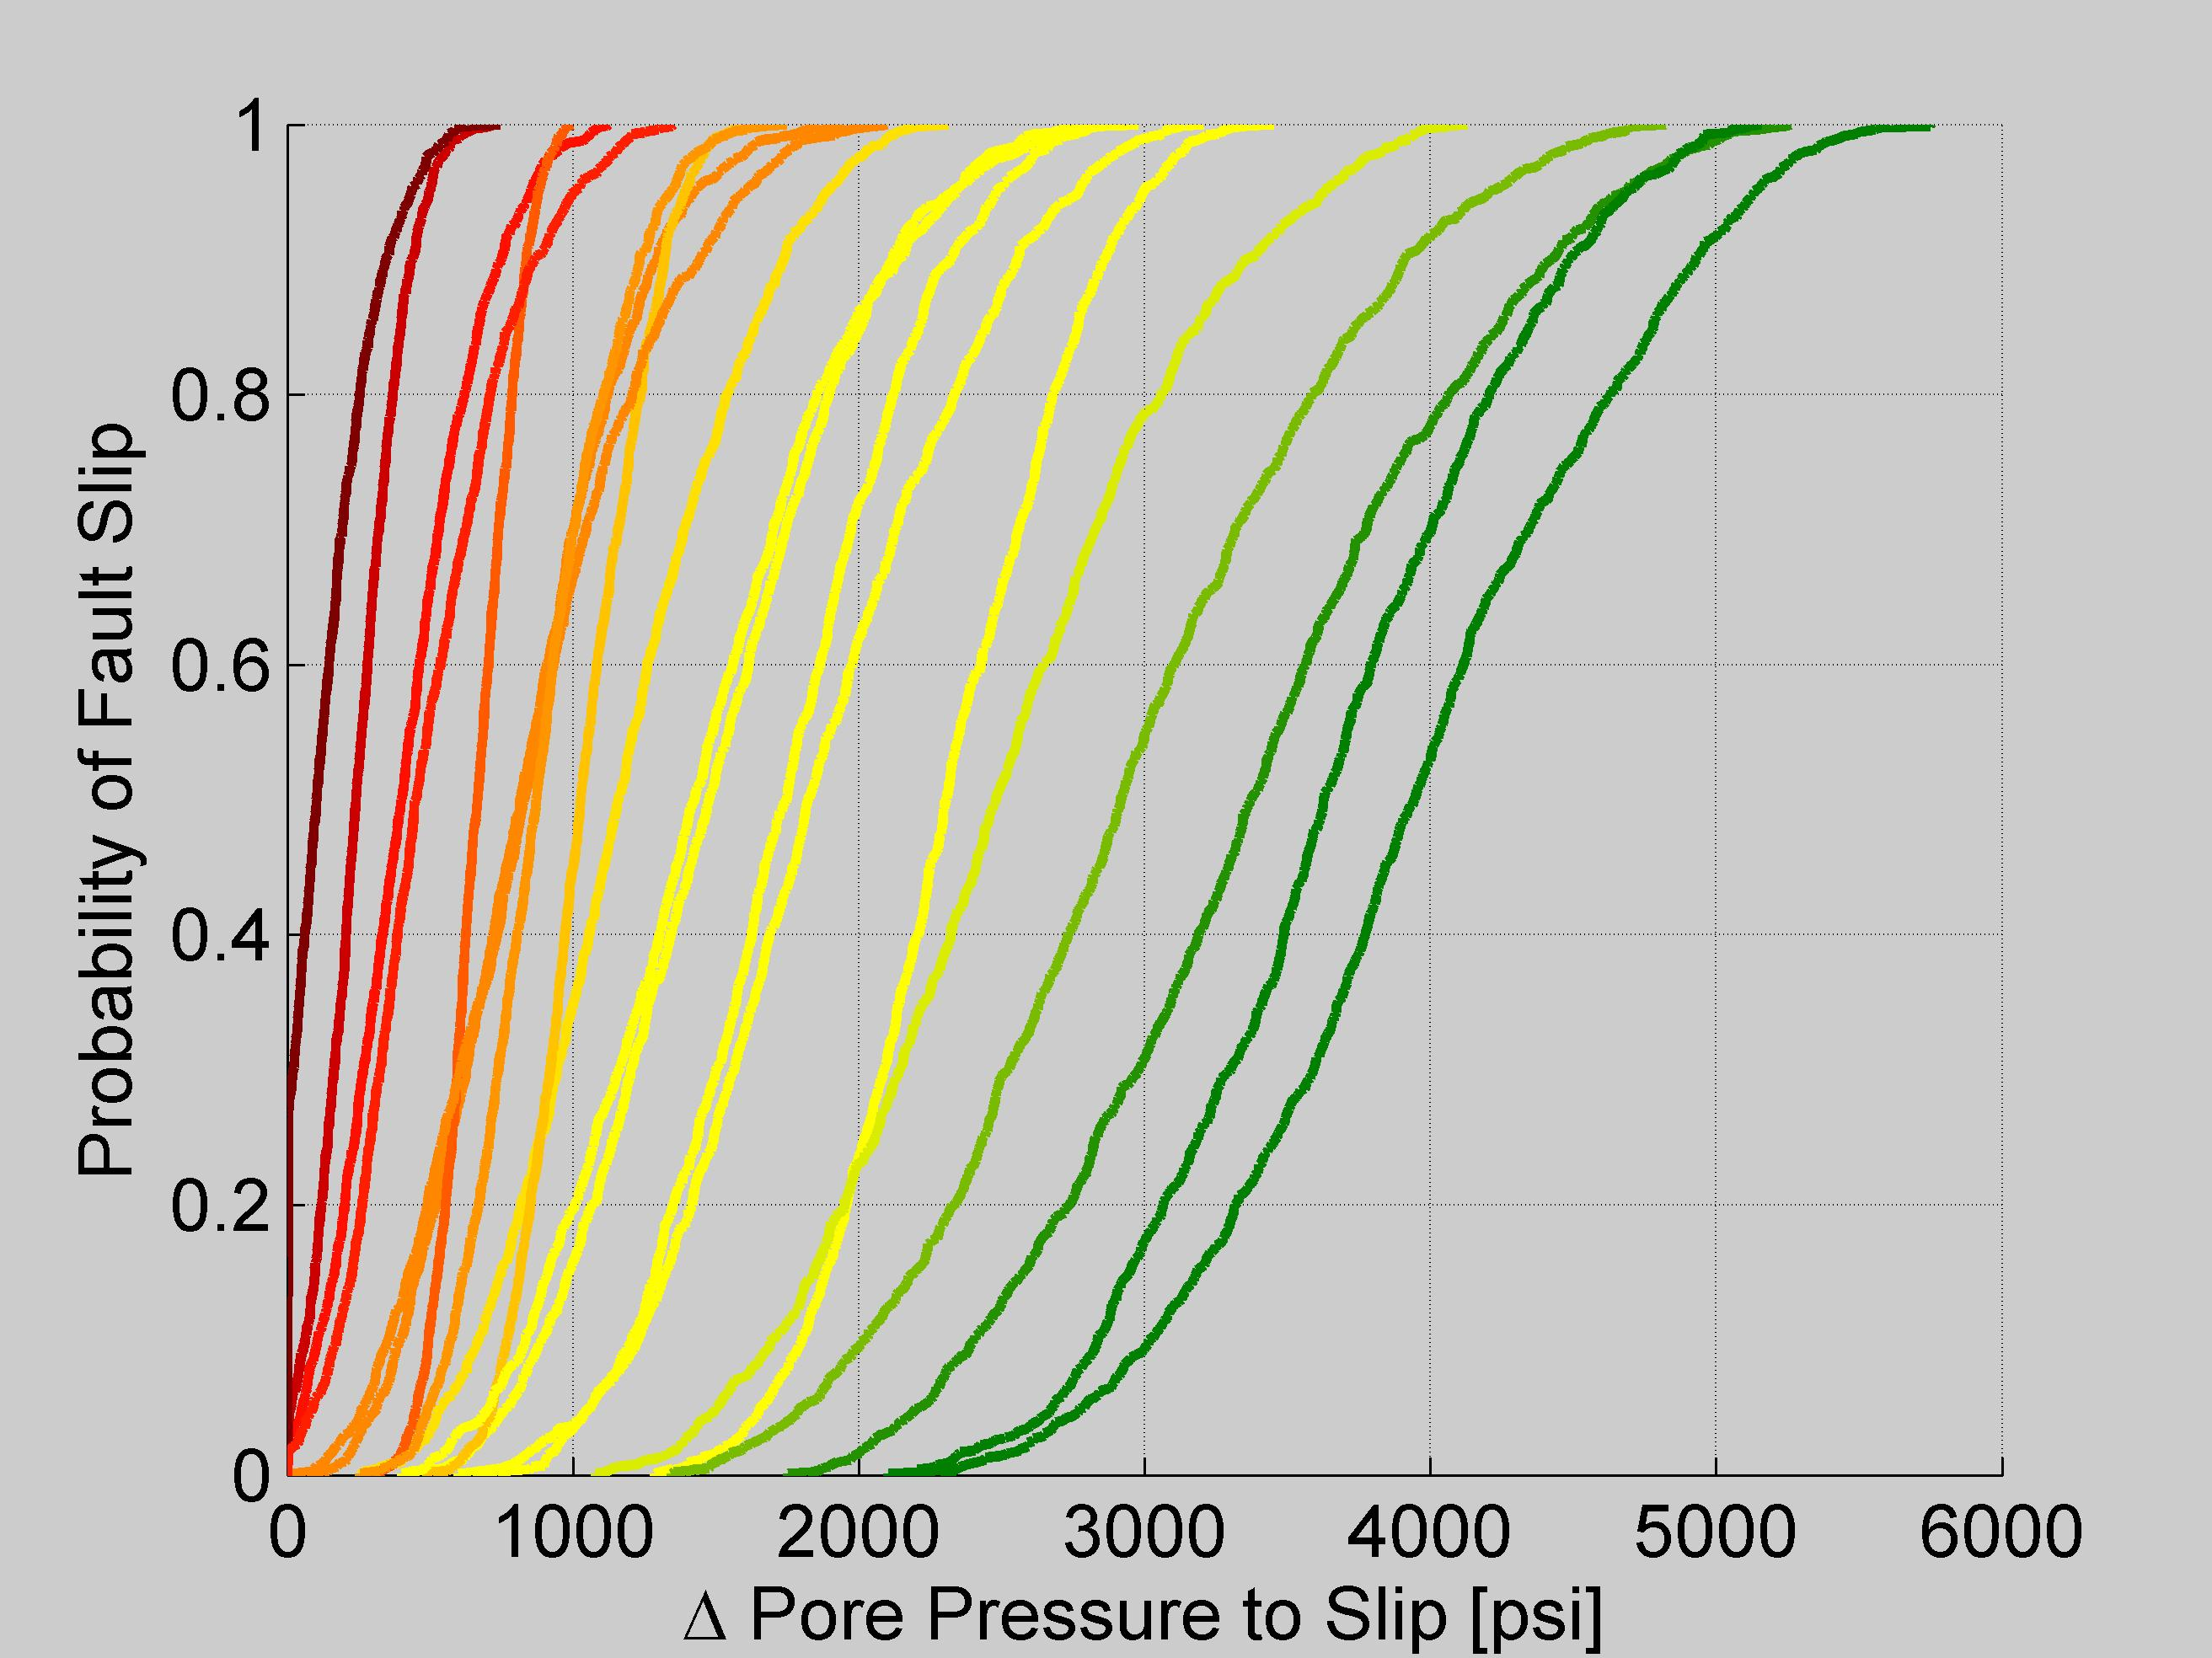

**Figure 9.** Probability of fault slip as a function of pore pressure increase on each fault segment. Each curve represents the mapped fault of the same color in the geomechanics tab.

### Sensitivity Analysis

A simple sensitivity analysis allows us to see the impact of uncertainty on the model results for each input. Figure 10 is a tornado chart that shows how the deterministic answer changes if each parameter is at its lower or upper bound. The parameters are ranked based on the degree of variation in the resultant pore pressure to slip. By ranking the relative impact of uncertainties in each parameter, the chart allows the user to determine which additional data would reduce the uncertainty most effectively.

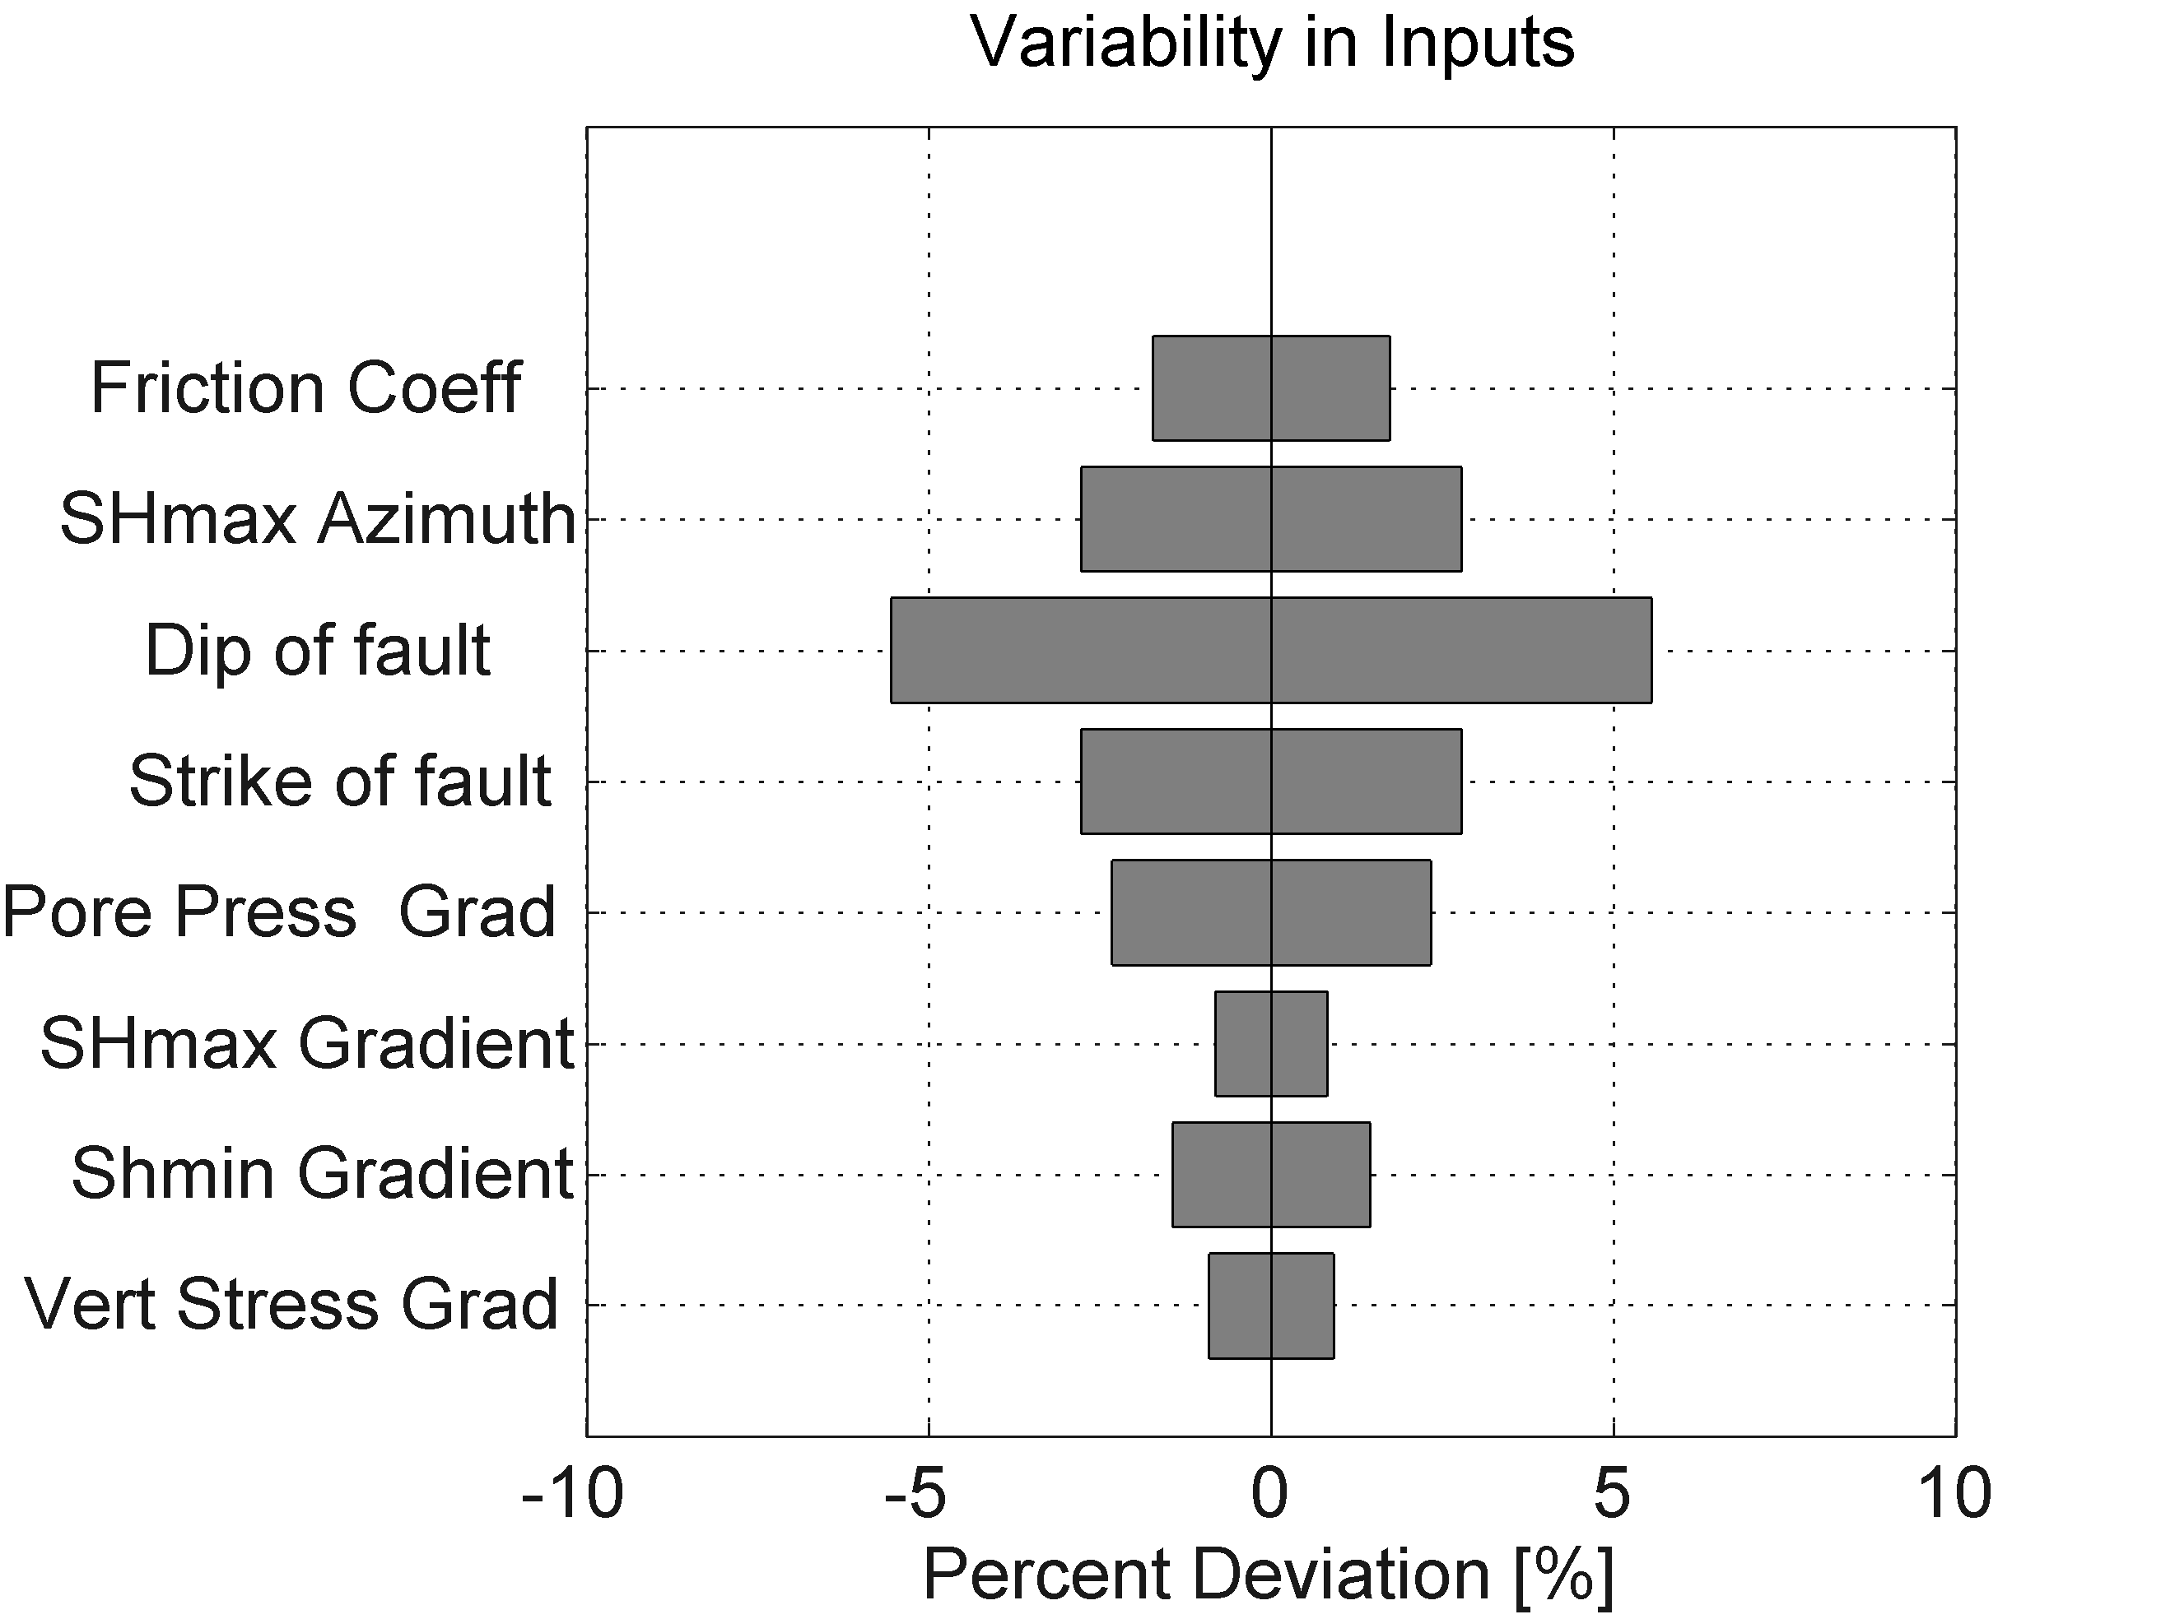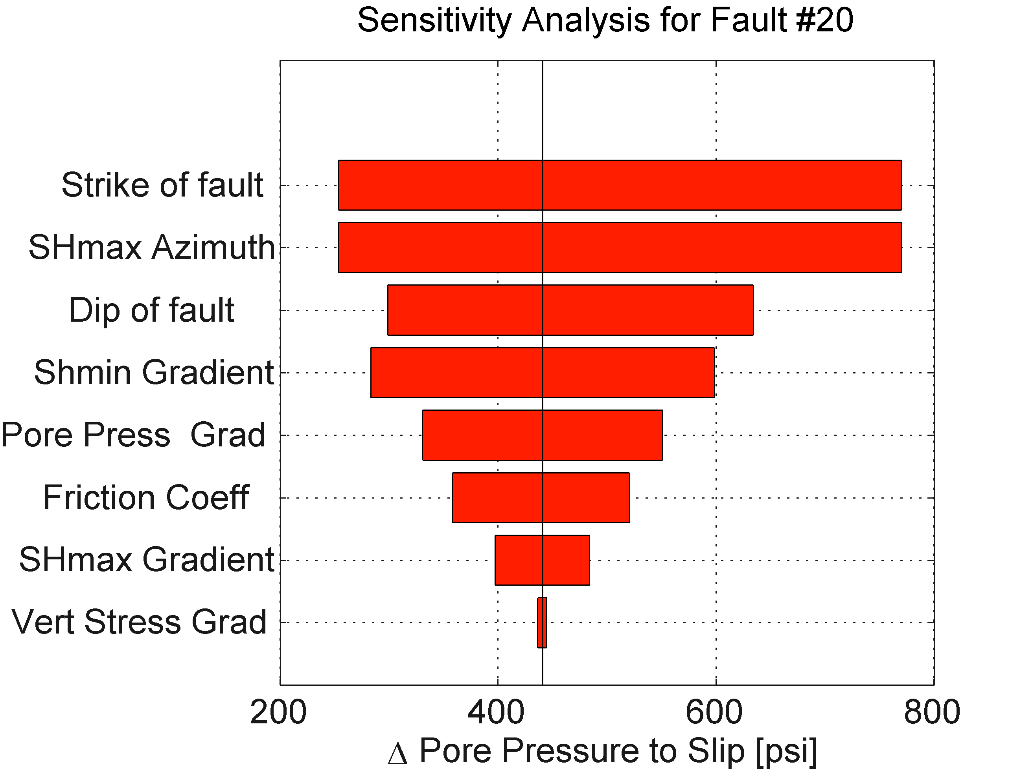

B.

A.

**Figure 10.** (A) Percent variability of uncertain inputs for fault number 20; (B) sensitivity of fault number 20 to uncertainties in various input parameters. In the case of fault #20, the result is most sensitive to SHmax azimuth and the strike of the fault. Although both the strike and dip of this fault have uncertainties of +/- 5 degrees (Figure 8), in the case of fault #20, the answer is more sensitive to fault strike than fault dip.

## Deterministic Hydrology Tab



### Tab Overview

Injection of fluids into a porous medium causes an increase in pore pressure that decays exponentially to background pore pressure with radial distance from the injection source. This pressure change radiates away from the well axisymmetrically as injection continues. Pressure change as a function of distance from each of the four wells in our example is shown in Figure 11. The model calculates a radially symmetric pressure profile for each well at a given time using Equation 3 from Hsieh and Bredehoeft (1981). This formulation of the groundwater flow equation calculates 2D radial flow in a vertically confined aquifer containing a variable injection rate well. At the start of injection, the porous medium is fully saturated, with a uniform pressure distribution. Injection wells are treated as point sources in the 2D grid; interacting pressure plumes are superimposed linearly. In the model, increase in fluid pressure is treated as constant in depth within the aquifer. The pressure field is queried at the center point of the mapped fault. While the geomechanics treats the fault as dipping, the 2D nature of the hydrologic model necessarily treats the fault as though it is vertical when calculating pore pressure on it.

For any number of reasons, it may be decided that this model is not the appropriate hydrologic model, for example because of bounds to the reservoir, structural or stratigraphic complexities. In this case, an external hydrologic model result can be imported; the imported data will override the internal hydrologic modeling. This is described in further detail in the hydrology data inputs menu section. In short, results can be imported as a spreadsheet containing X and Y coordinates at the depth of interest, pressure increase in PSI at that depth and 4 digit year. Imported data will be interpolated onto Figure 12A and onto each fault using a triangular gridded interpolation.

### Using the Tab

The deterministic hydrology tab calculates results for January 1st, 12:01 AM in the year selected in the slider bar: 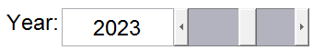. FSP evaluates injection up until the selected time to calculate pressure as a function of distance from the wells. The increase in pressure from each well is linearly superimposed at a given point on the map (Figure 12a) to produce the full pressure perturbation on each fault. Figure 12b shows the evolution of the deterministic Mohr circle (Figure 6a) in the selected year on the selected fault(s). The fault’s dot and Mohr circle have shifted slightly to the left because increasing fluid pressure has pushed the fault closer to the red slip line. The current hydrologic model does not consider poroelastic stress changes when calculating fault effective stress, but this feature could be added in future versions of FSP.

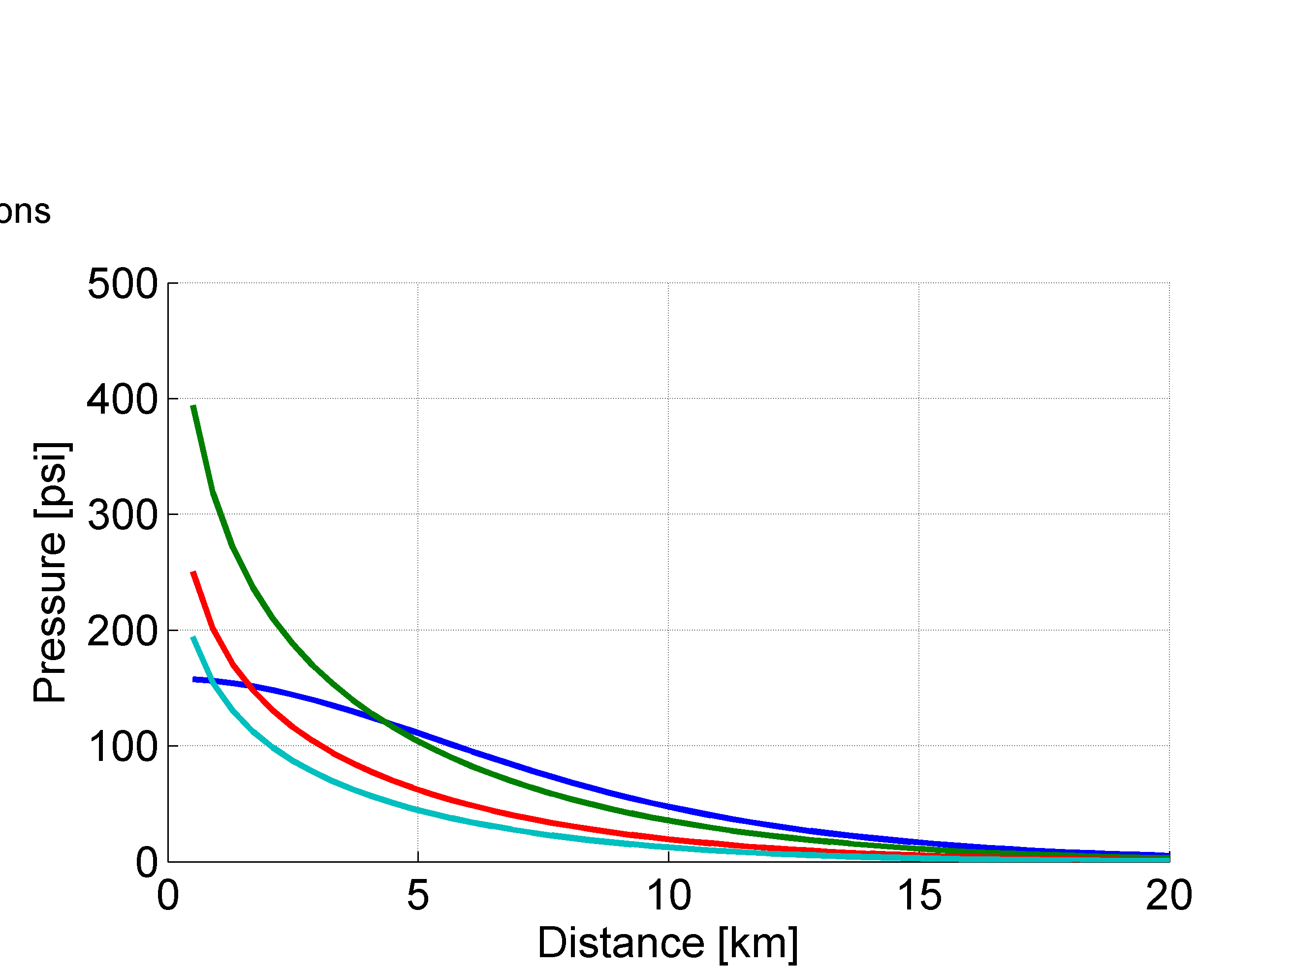

**Figure 11.** Increase in fluid pressure (in PSI) above natural levels due to injection in each of the 4 wells as a function of distance in model year 2023. The curve for well #1 has a different concavity than the others because it recently ceased injection (see Figure 5 for injection rates), while the others continue to inject.

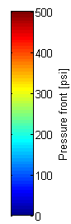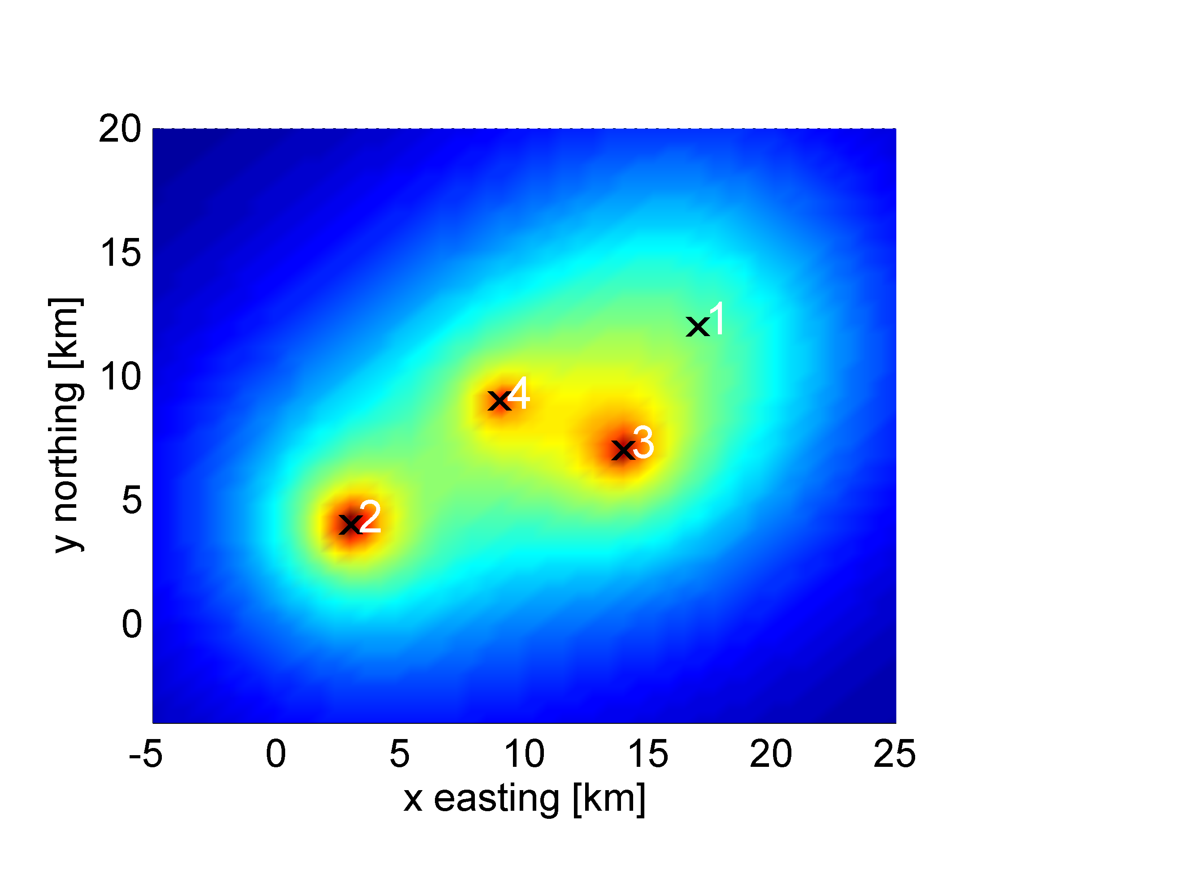

A.

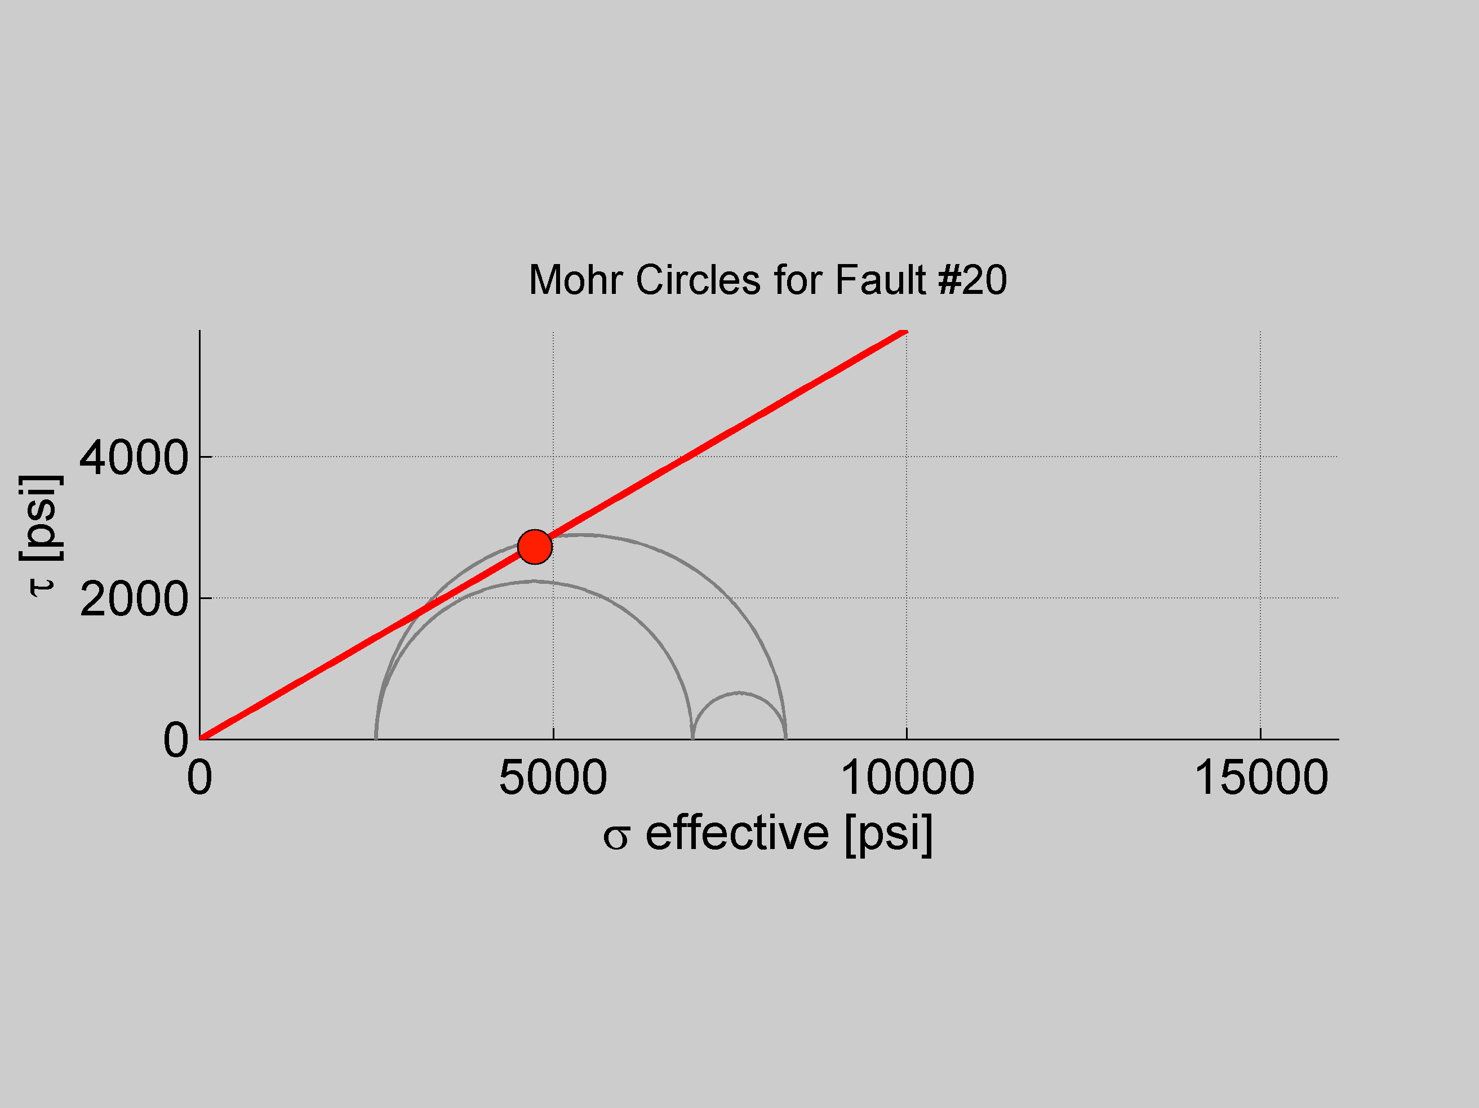

B.

**Figure 12.** (A) Fluid pressure perturbation from each well linearly superposed onto the mapped domain; (B) evolution of the Mohr diagram (Figure 6a) - increasing fluid pressure on the selected fault in the selected year shifts the circle to the left.

## Probabilistic Hydrology Tab



### Tab Overview

Here we combine the hydrology with the probabilistic geomechanical CDF from that tab. It can be either deterministic hydrology from the previous tab, or it can be probabilistic hydrology as outlined in the “Using Probabilistic Hydrology” section below. In the case of an imported hydrologic model, the deterministic approach is required because an imported pressure model cannot be iterated within FSP. In the case of many well-months (~5,000) of injection data points, the hydrologic calculation can be comparatively slow even without Monte Carlo iteration.

In cases involving fewer well-months of variable injection data, constant injection rates, or more patient program users, probabilistic hydrology calculations should be incorporated. Just as it does for probabilistic geomechanics simulations, FSP implements Monte Carlo simulation, allowing uncertainties in input parameters to be propagated through the model. The result is a probabilistic distribution of potential increases of pressure on the fault reflecting the input uncertainties.

### Using Deterministic Hydrology to Calculate Slip Potential

Once we have calculated the pore pressure added to a given fault and the probability of fault slip as a function of pore pressure increase, we can calculate the cumulative probability of fault slip. We do this simply by slicing the probability shown by the CDF curve (from Figure 9) for the appropriate pore pressure increase (as shown for the selected fault and the selected year in Figure 13).

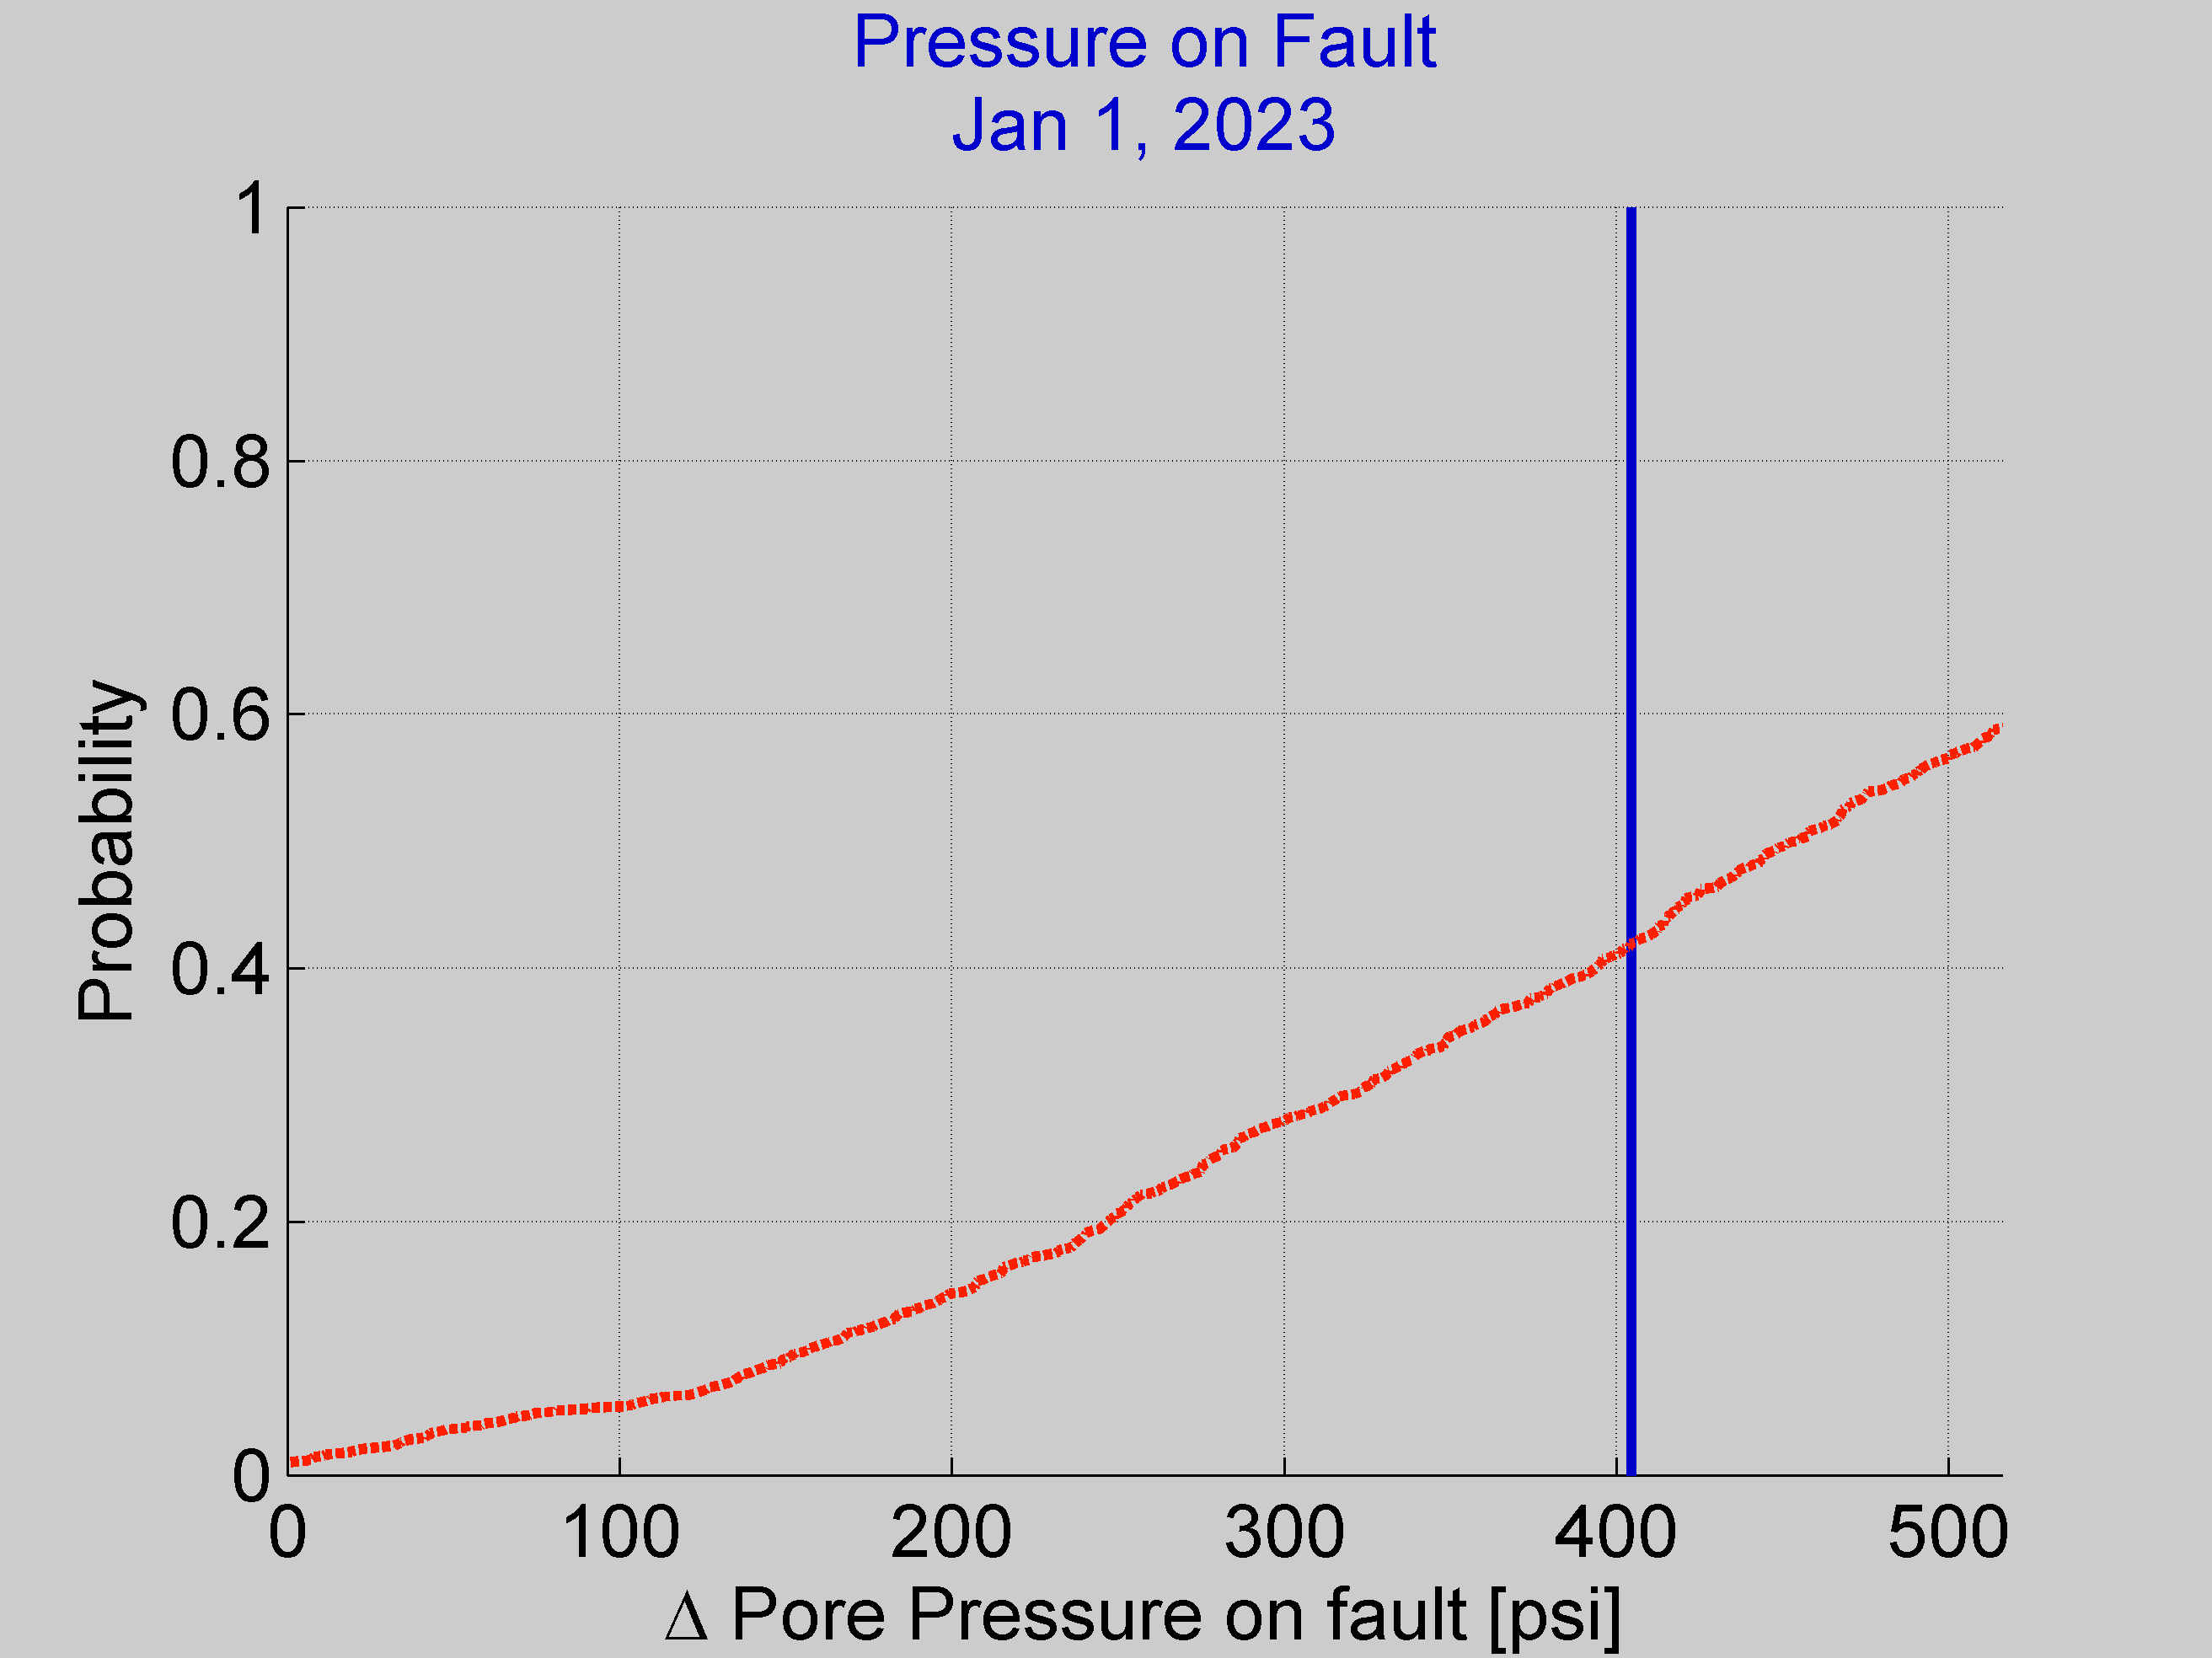

**Figure 13.** Calculating fault #20’s slip potential in the year 2023 by reading the value of the CDF curve at the pressure increase value associated with that year (vertical blue line). The result is 0.44, or a 44% cumulative probability of fault slip for the year 2023. Note that the results show a nonzero slip potential (about 1%) even when no fluid pressure is added to the fault. This reflects the uncertainties in the initial model, and could represent the possibility that the fault has already slipped in recent geologic history, or that stress uncertainties are comparatively large.

Whether deterministic or probabilistic hydrology (if possible) is used to calculate slip potential is set in the radio buttons of the menu shown below.

### Using Probabilistic Hydrology to Calculate Slip Potential

The hydrologic parameters for which uncertainty can be assessed in FSP are injection aquifer thickness, porosity, permeability, injected fluid density, dynamic viscosity, fluid compressibility, and rock compressibility. In FSP, all these values are described by uniform probability distribution functions centered on the deterministic value. The range of values is entered for each parameter as a plus/minus value in the  menu shown below. 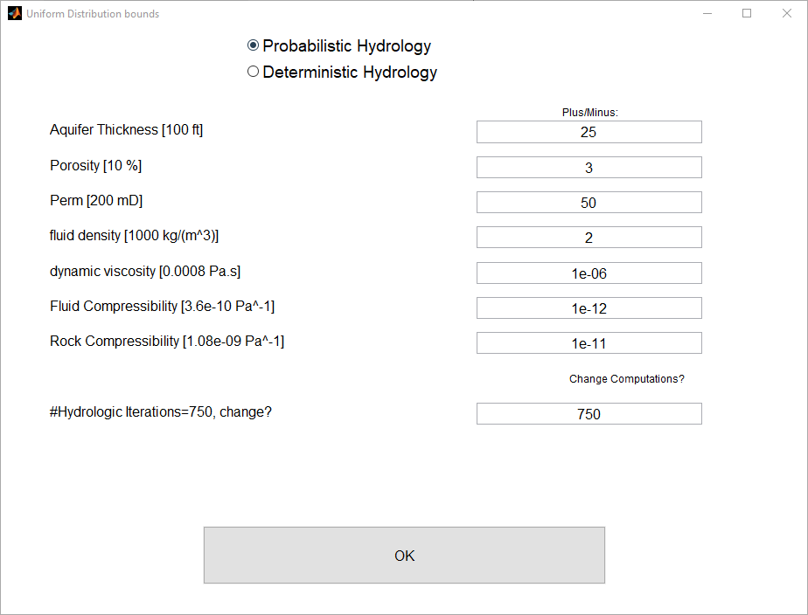

The range of uncertainty is determined by adding and subtracting the values entered in the plus/minus field above from the deterministic values, shown next to each input label. Setting the uncertainty to zero results in a constant parameter value across all iterations. By extension, setting all uncertainties to zero produces the same answer as the deterministic calculation in every iteration. Choosing the “Deterministic Hydrology” radio button bypasses the probabilistic calculation by setting all uncertainties to zero and running the calculation deterministically (once). The plus/minus value cannot be greater than the deterministic value, as this would imply a negative parameter value in some iterations. Unlike the probabilistic geomechanics calculation, which is fixed at 1,000 iterations, the number of Monte Carlo iterations run by the probabilistic hydrology model can be prescribed in the field “#Hydrologic Iterations”. A greater number of iterations results in a smoother distribution but will increase the model run time.

Figure 14 shows the uniform distributions (in red) calculated using the plus/minus values entered in the menu above. The actual distribution of values inputted during Monte Carlo iteration is shown by the blue histogram bars. The last subplot in the bottom right of Figure 14 shows the probabilistic hydrology model results: the probabilistic distribution of fluid pressure increases on the selected fault in the selected year.

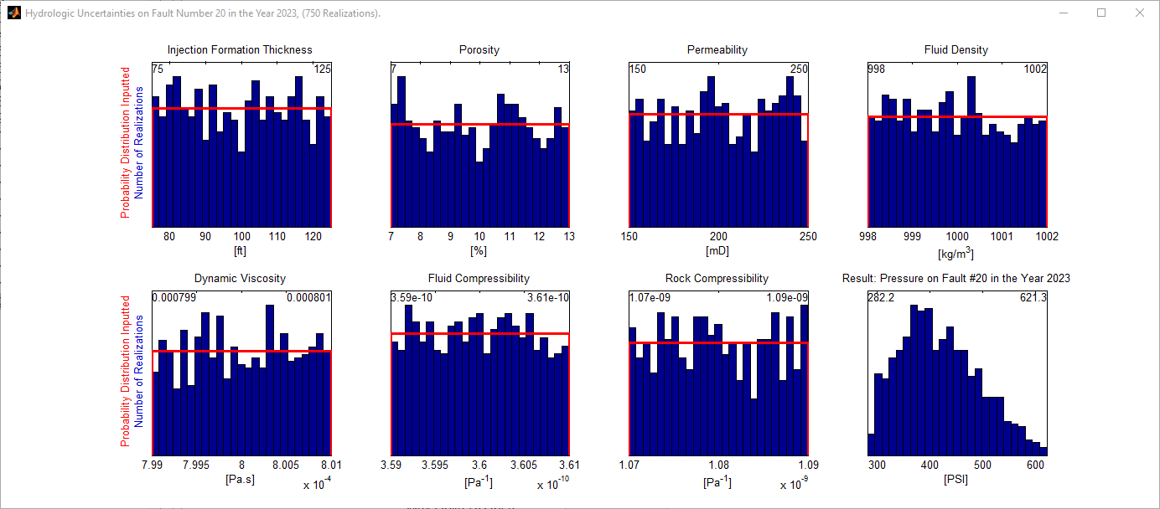

**Figure 14.** Uniform distributions of each parameter uncertainty entered are plotted in red, with bounds labeled in the upper corners of the plot. Each blue histogram shows the actual distribution of each input randomly sampled during Monte Carlo iteration. The model result, a probabilistic distribution of pore pressure increases on the selected fault, is shown in the bottom right subplot. In this case, the simulation suggests that between 282.4 and 645.4 PSI will be added to fault #20 in 2023. This same information is encompassed in the probability of exceedance curve in figure 15.

The result of the Monte-Carlo hydrology simulation is a probabilistic distribution of pressures summarized as a histogram (see Figure 14). FSP also shows the same result as a probability of exceedance curve (Figure 15). The final step is to take the probabilistic geomechanical CDF result into account to produce a single Fault slip Potential value. In a discrete sense, the FSP is calculated for each of the many possible hydrologic models. Because each model is equally probable, the mean of these FSPs is then taken as the faults’ slip potential.

In this example, the hydrologic uncertainties are small relative to the geomechanical uncertainties; the resulting slip potential is still 0.44 for this fault, just as it was in the deterministic case. This won’t always be the case. For example, if the deterministic pressure on the fault were close to, but just to the left of the CDF, the FSP would be zero. If probabilistic hydrology were then used in this case, some iterations could still show that the pressure could increase on the fault to reach the CDF curve, resulting in a nonzero slip potential.

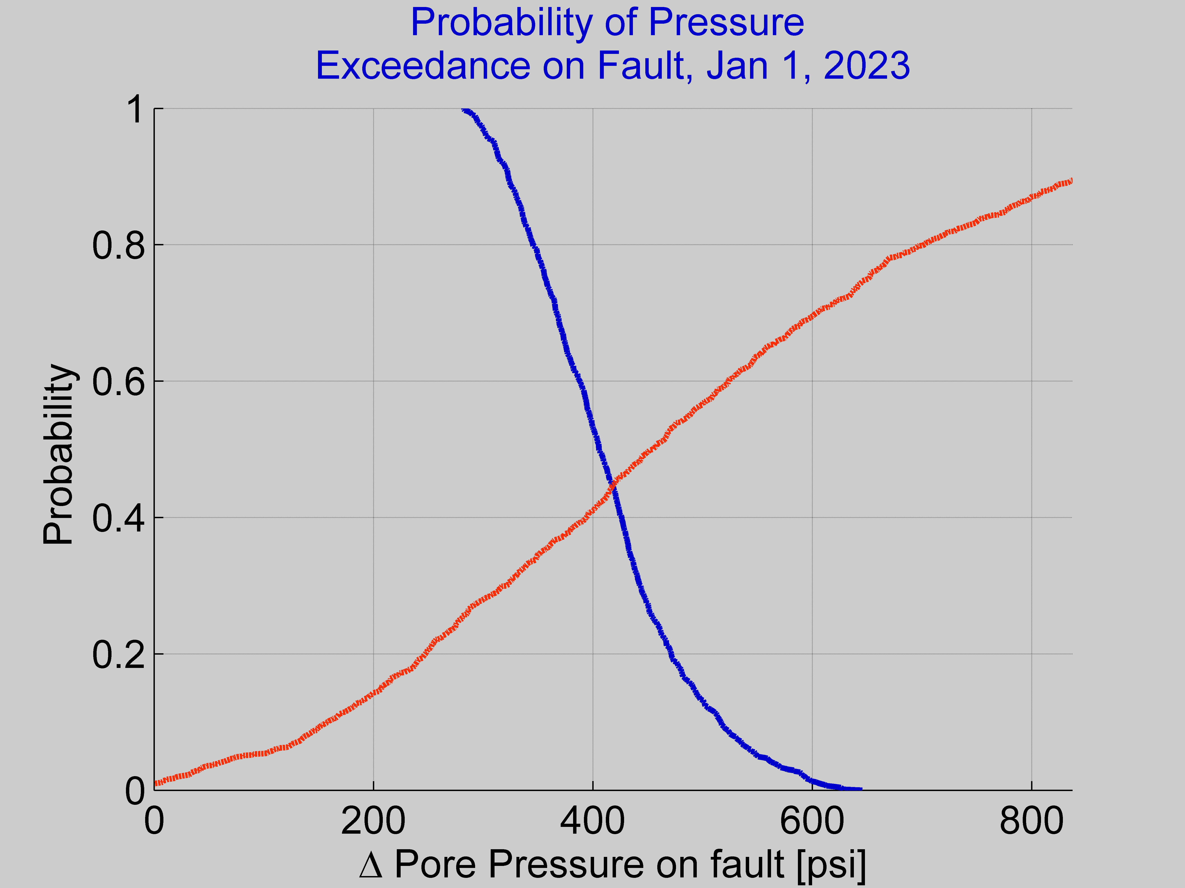

**Figure 15.** Probability of pressure exceedance on fault number 20 on January 1, 2023 (blue curve). The orange curve shows the conditional probability of fault slip as a function of pressure increase on the fault. For this fault in this year, there is a 44% slip potential. If the blue curve were entirely to the left of the dashed curve, there would be zero slip potential on the fault. If it were entirely to the right, it would be 100%. Though here the result is the same as that calculated with deterministic hydrology, this will not always be the case.

## Integrated Tab: Summarizing Results



### Tab Overview

The integrated tab is designed to show the combined results of probabilistic geomechanics and hydrology models for all faults under consideration. Figure 16 shows the mapped domain, with each fault labeled by its number and colored according to the color scale chosen within the integrated tab. The color scale can be modified because different institutions or individuals may have different tolerances for fault slip potential. The color scale shown below is for illustration purposes and shouldn’t be considered a recommendation of tolerance.

### Using the Tab

Figure 16 is a map of faults and wells, with each fault colored by its Slip Potential for the selected year. In FSP, faults can be labeled by their index number, slip potential, or the pore pressure change on the fault. If the graphics renderer selected under the advanced tab is capable, an opaque map of the pore pressure change is shown in the background. This is taken from the “Hydrology” tab.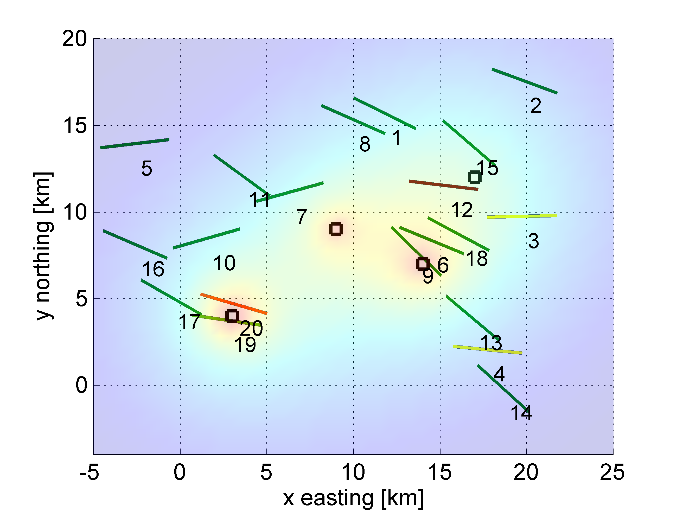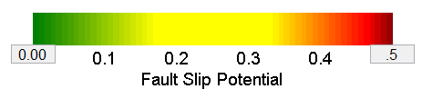

**Figure 16.** Mapped faults colored by their Slip Potential according to the color scheme shown in the accompanying color bar. We observe, for example, that faults 19 (green) and 20 (orange) are both close to well #2, but a slight difference in orientation means that fault #20 is considerably more likely to slip than fault #19. A similar case is observed for faults 12 and 15 near well #1.

If the “Summary Plots” button is pushed, figures 17 and 18 are generated by iterating over each model year on the slider. Note that this is the most computationally intensive button to push, because it cycles through the calculation for each year possible one after the other. Figure 17 shows the modeled evolution of pore pressure on Faults 19 and 20. The vertical green dashed line represents the year the model slider is set to. Figure 18 plots FSP through time for each fault, produced by repeating the calculation done in the “Probabilistic Hydrology” tab (as in Figure 13 or 15) for each model year. Faults with high FSP are faults where a high proportion of the probabilistic iterations result in slip of the fault. Faults with increasing FSP are faults where some, but not all, of the probabilistic models show faults moving from a stable to unstable state. In this case, fault #19 experiences a slightly higher magnitude pressure change than fault #20. Despite this, fault #20 has a higher slip potential (shown through time in Figure 18) because it has a more favorable orientation within the stress field.

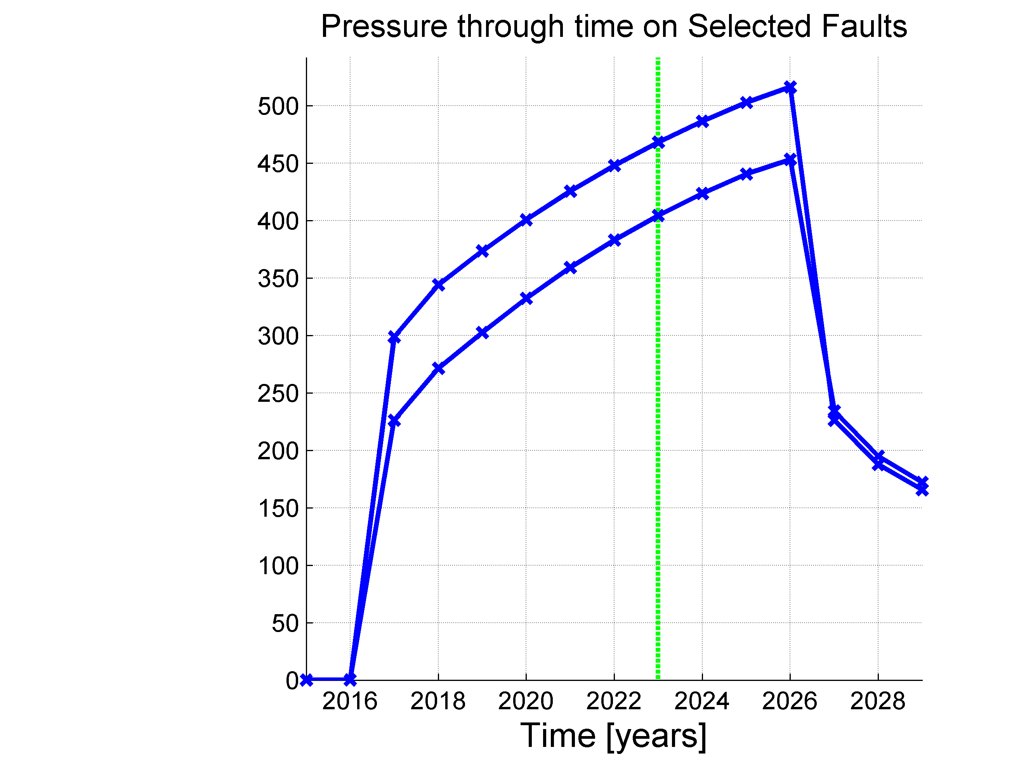

Fault #20

Fault #19

**Figure 17.** Fluid pressure on faults #19 and #20 over the duration of the modelled time period. The vertical dashed line shows the year the model is set to, 2023.

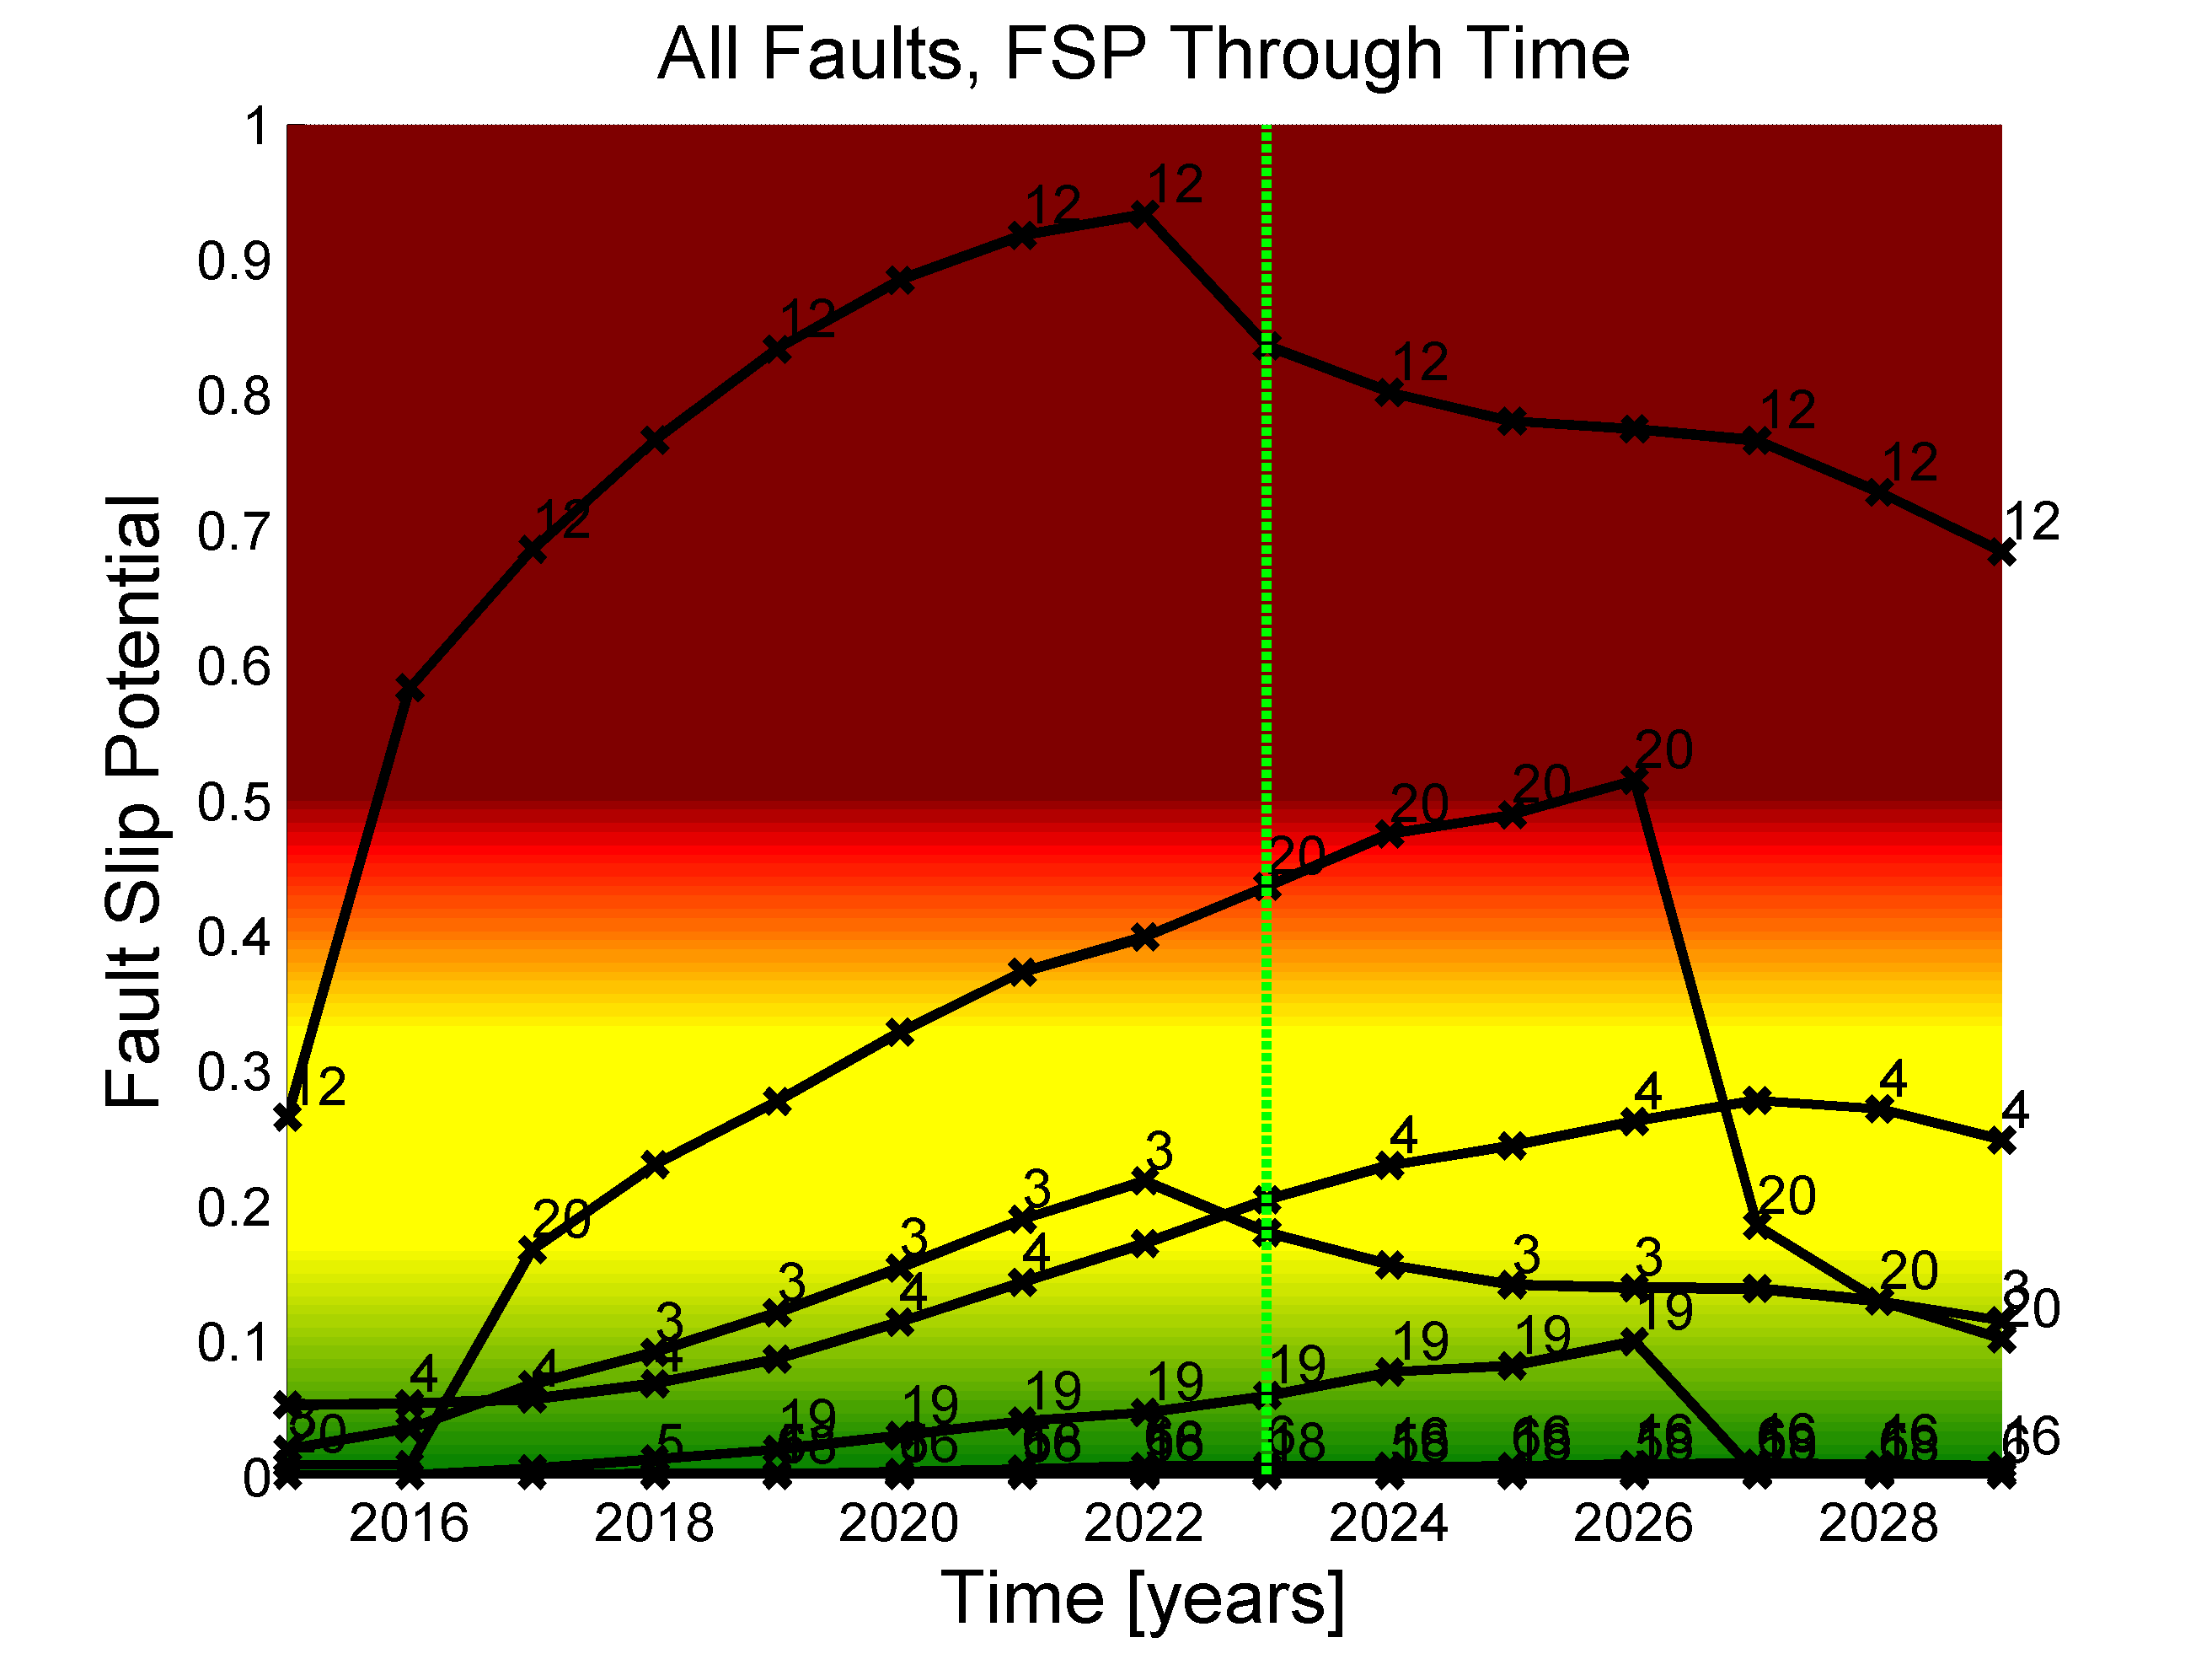

**Figure 18.** Evolution of fault slip potential over the duration of the modelled time period; selected curves are labeled by corresponding fault number. We can see that faults #12 and #20 have the highest slip potential. All else being equal, an operator or regulator might choose to inject smaller volumes of fluids near these faults. The green vertical line shows the year the slider is set to.

# User Interface Menus

## File Menu

The file menu allows users to save sessions, load previously saved sessions, load default data to view the generic case shown here, and quit the program. A copy of the license associated with the software is available under “License”, and is also printed in the license section of this document below.

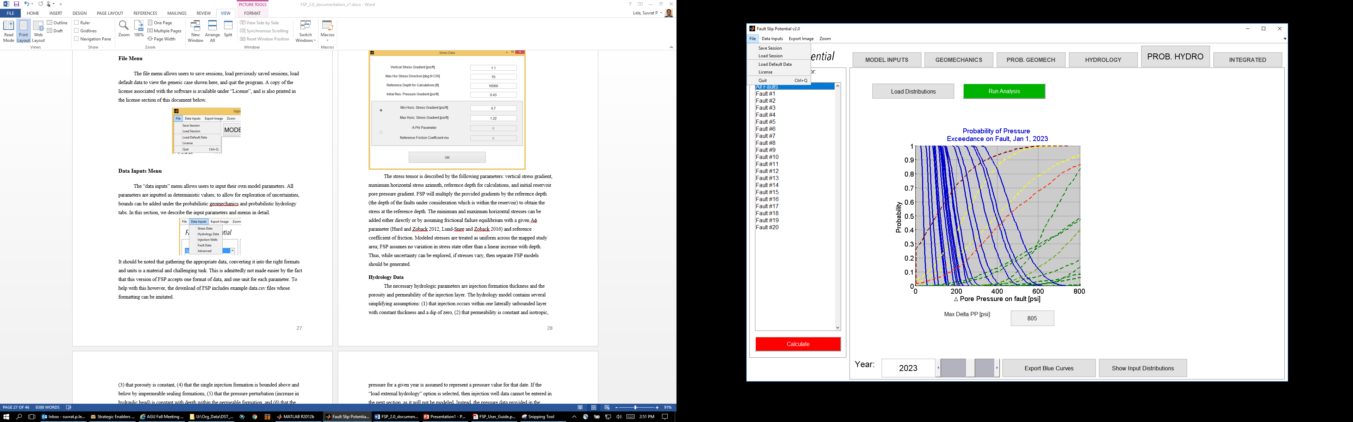

## Data Inputs Menu

The “data inputs” menu allows users to input their own model parameters. All parameters are inputted as deterministic values; to allow for exploration of uncertainties, bounds can be added under the probabilistic geomechanics and probabilistic hydrology tabs. In this section, we describe the input parameters and menus in detail.

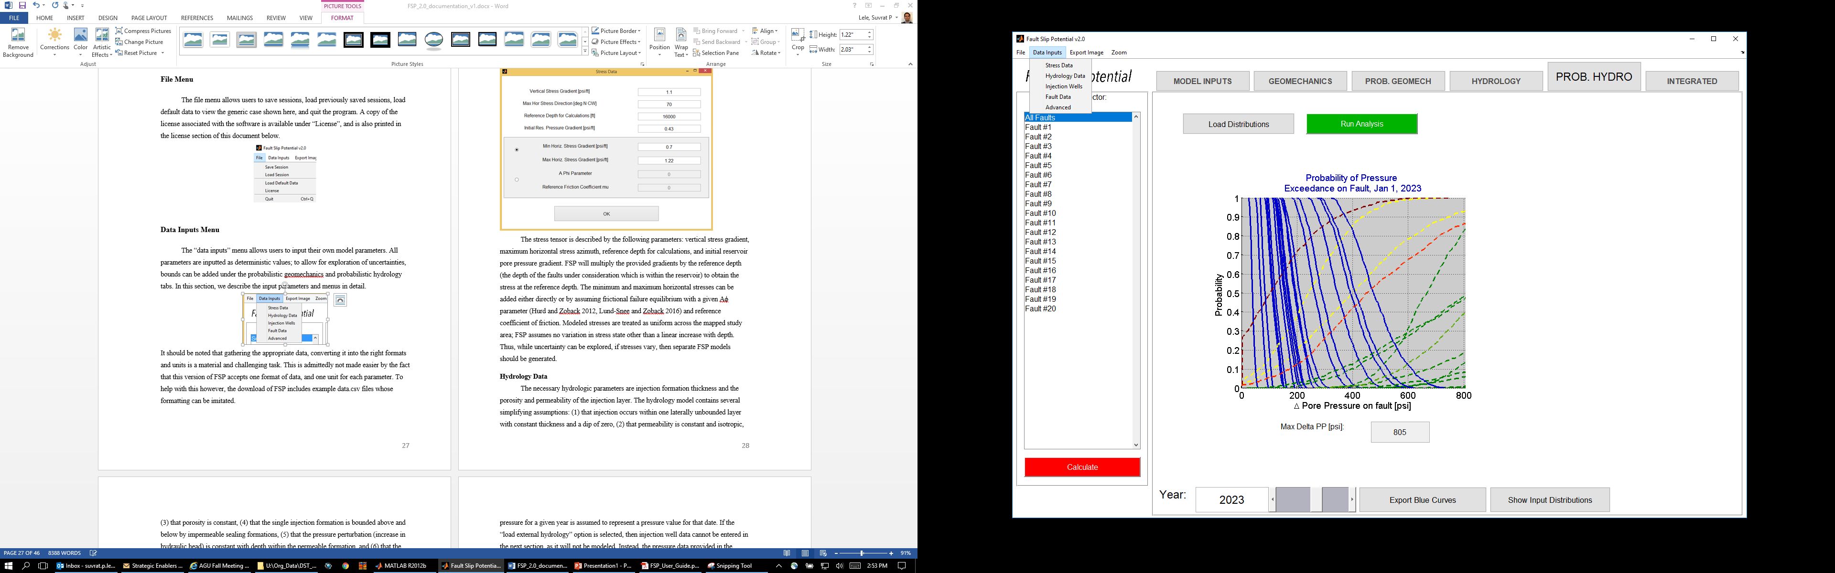

It should be noted that gathering the appropriate data, converting it into the right formats and units is a material and challenging task. This is admittedly not made easier by the fact that this version of FSP accepts one format of data, and one unit for each parameter. To help with this however, the download of FSP includes example data.csv files whose formatting can be imitated.

### Stress Data

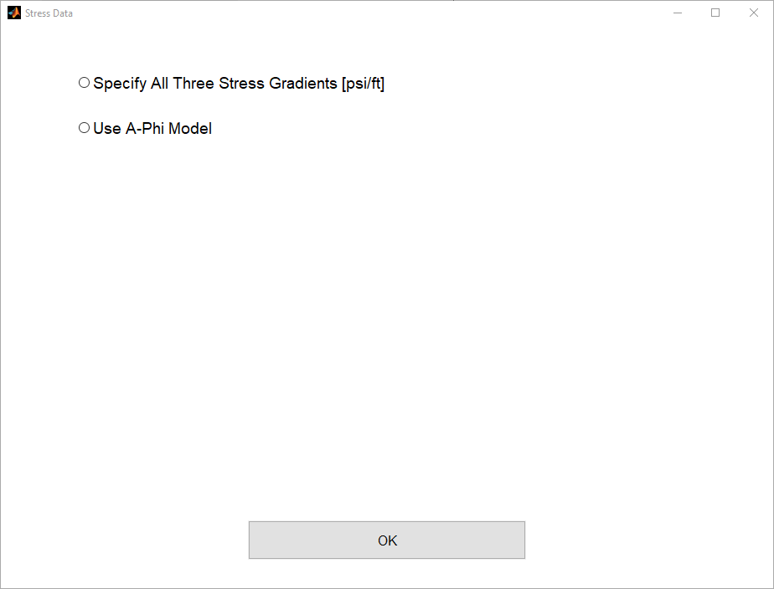

The stress tensor is described by specifying gradients for all three stresses, vertical, maximum horizontal and minimum horizontal stresses. If the horizontal stress gradients are not available, A-Phi model (Hurd and Zoback 2012, Lund-Snee and Zoback 2016) that estimates the horizontal stresses based on critical stress assumption may be used. The pore pressure gradient, reference depth for calculation, and maximum horizontal stress direction are required with both above options. FSP will multiply the provided gradients by the reference depth (the depth of the faults under consideration which is within the reservoir) to obtain the stress at the reference depth.

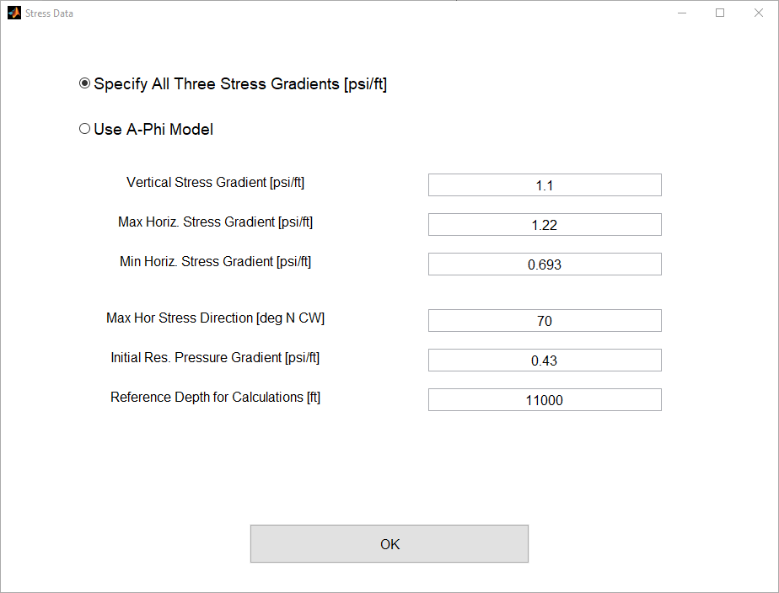

Modeled stresses are treated as uniform across the mapped study area; FSP assumes no variation in stress state other than a linear increase with depth. Thus, while uncertainty can be explored, if stresses vary, then separate FSP models should be generated.

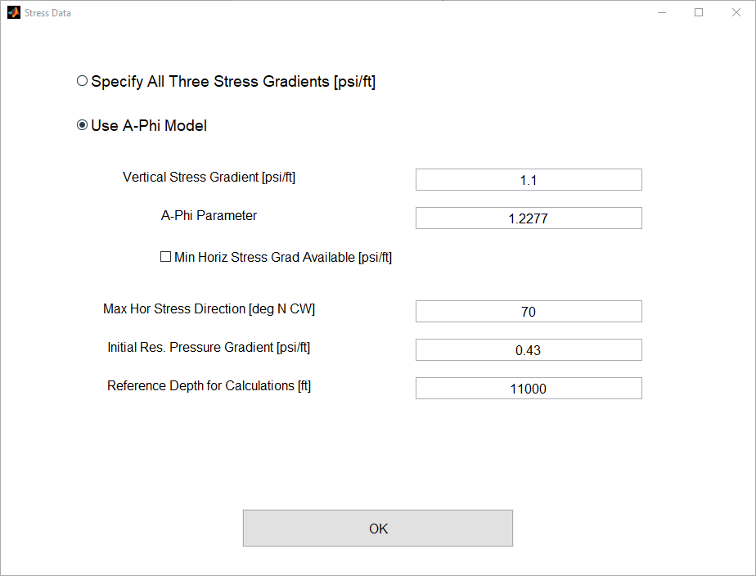

A-Phi stress model calculates horizontal stresses based on stress criticality assumption, such that the largest Mohr circle is tangent to the failure line corresponding to a *reference friction coefficient*. This reference friction coefficient is assumed equal to the fault friction coefficient (specified with fault data) to simplify the model inputs.

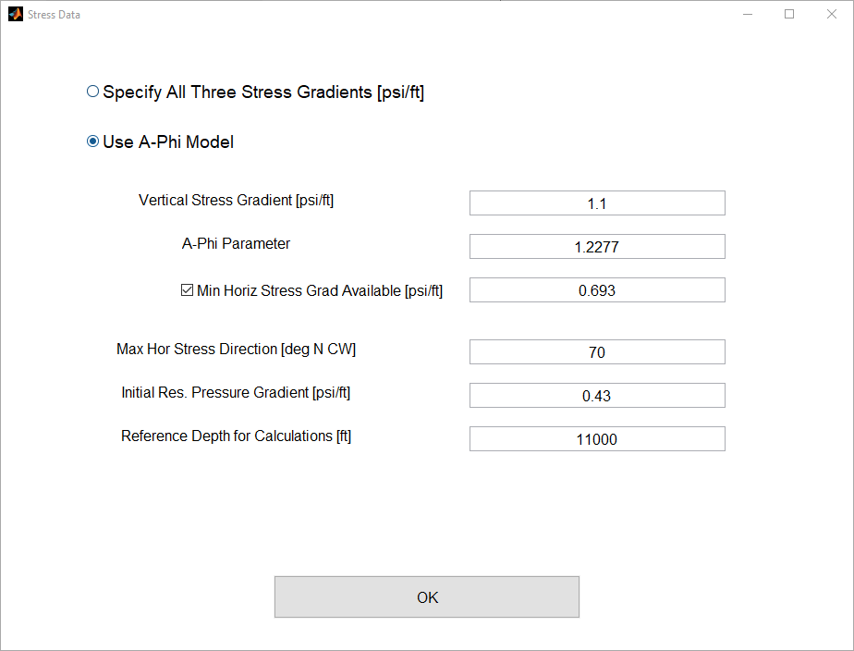

Horizontal minimum stress information is generally available for more cases compared to the maximum stress. This minimum horizontal stress, when available, may be used to improve accuracy of A-Phi stress model. This value is used in place of the internal reference friction coefficient parameter and removes the need for stress criticality assumption, hence allowing better representation of possible stress states (which may not always be critical).

### Hydrology Data

The necessary hydrologic parameters are injection formation thickness and the porosity and permeability of the injection layer. The hydrology model contains several simplifying assumptions: (1) that injection occurs within one laterally unbounded layer with constant thickness and a dip of zero, (2) that permeability is constant and isotropic, (3) that porosity is constant, (4) that the single injection formation is bounded above and below by impermeable sealing formations, (5) that the pressure perturbation (increase in hydraulic head) is constant with depth within the permeable formation, and (6) that the injection well is open over the entire depth of the permeable injection formation. More details on the model can be explored in Hseih and Bredehoeft (1981).

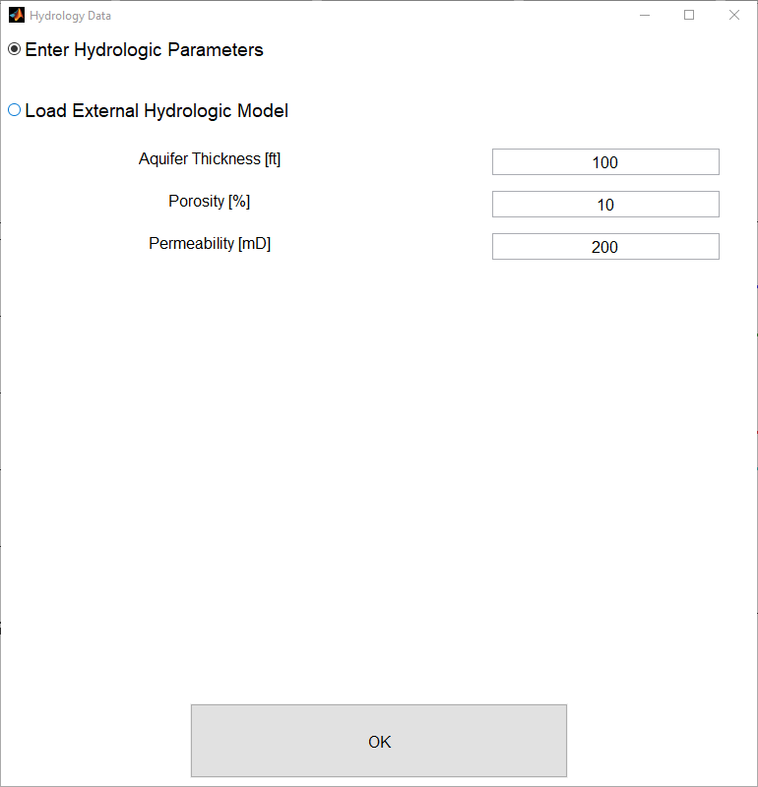

Additional hydrologic parameters, including the fluid density, dynamic viscosity, fluid compressibility, and vertical rock compressibility, can be entered under the advanced tab. FSP uses these parameters to calculate formation storativity and transmissivity.

Alternatively, if pore pressure perturbations are available from an external hydrologic model, they may be imported into FSP instead of running the internal FSP hydrologic calculation by selecting the appropriate radio button above.

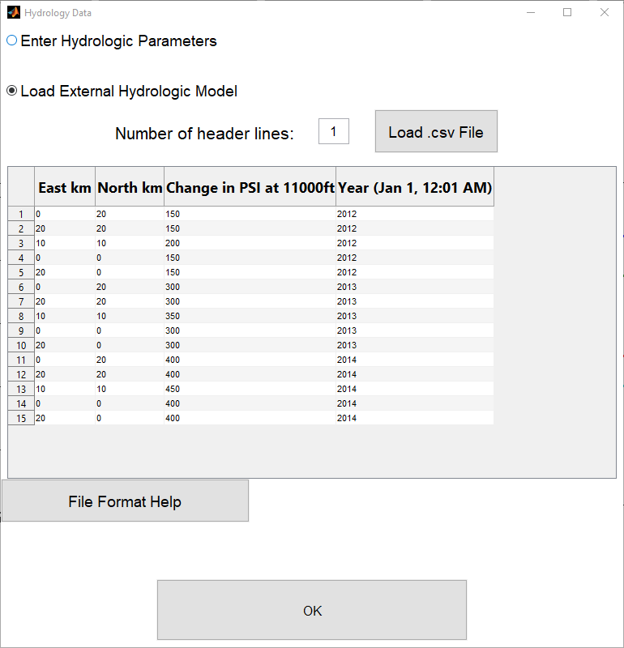

Data can be imported as a .csv file containing Northing and Easting coordinates (in kilometers, as two columns), increases in pressure in PSI above the initial reservoir pressure entered under the Stress data menu in the third column, and the 4 digit year in the fourth column. An example file is included, labeled “exampleHydrologyModelRisingPressure.csv”. Because FSP calculates hydrology once per year (on January 1st, 12:01 AM), the imported pressure for a given year is assumed to represent a pressure value for that date. If the “load external hydrology” option is selected, then injection well data cannot be entered in the next section, as it will not be modeled. Instead, the pressure data provided in the external file will be spatially interpolated onto each fault through a gridded interpolation.

### Injection Well Data

Injection well data describes the injection rate profile of each well over time as is shown in figure 5. Injection well data can be provided in one of two different ways:

First, up to 8 wells with constant injection rates (in barrels per day) can be provided; the start year and end year fields allow for simulation of wells only active for part of the injection period. As noted above, FSP will assume injection starting and ending January 1st, 12:01 AM of the provided year.

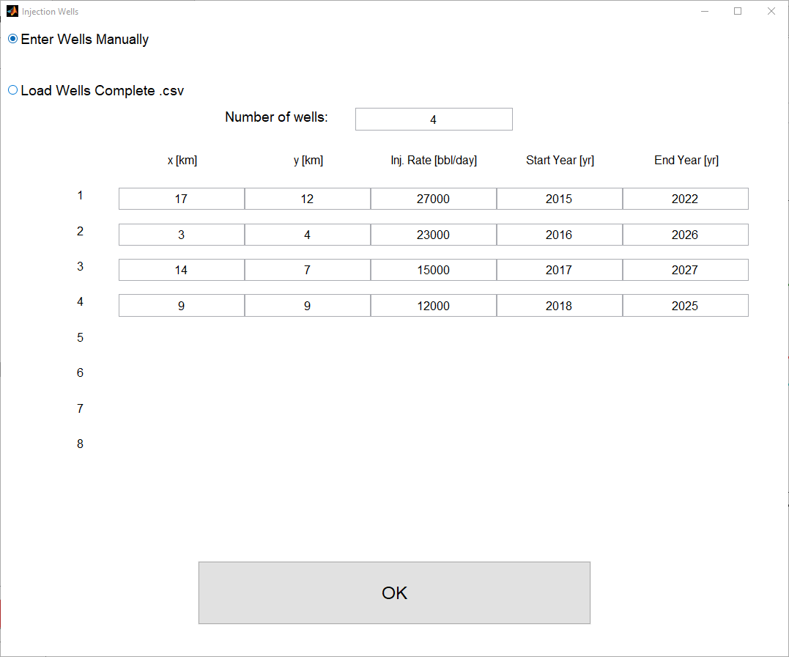

Alternatively, monthly injection data from up to 100 wells can be provided in the form of a .csv spreadsheet containing the following columns: (1) unique well identifier (e.g. well name or API number), (2) Easting and (3) Northing coordinates (km), (4) four digit year (e.g. 2014), (5) month number (eg. 1-12), and (6) injection volume (barrels injected in that month). If more than 100 wells need be analyzed in one model, see Advanced Startup Specifications below.

FSP will decide which set of data to use (manually entered data, or loaded monthly data) based on the radio button selection at the top of the menu, and will not take both types of well data at the same time. If monthly data are loaded, it’s important that they have undergone quality control to ensure that each well has one unique name, one coordinate, and no repeated month entries. There is a limit to the number of unique wells accepted, but no limit to the number of months that each well can inject for. If “extrapolate injection?” is checked, the model will take the last monthly injection rate and extrapolate it to the end of the model time.

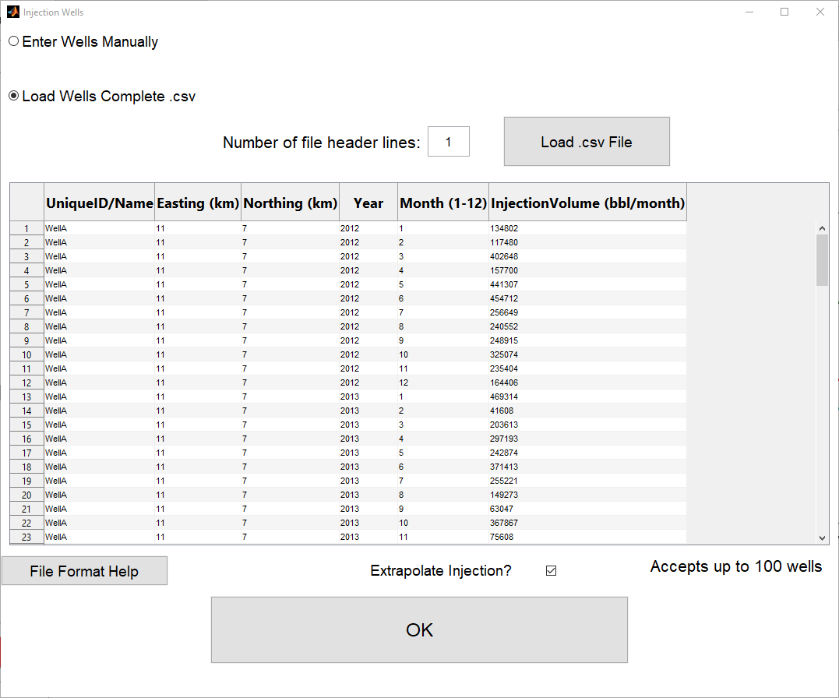

### Fault Data

Like injection well data, fault data can be provided by either of two methods (depending on which radio button is selected at the top of the “Fault Data” window. The first method, “random faults” generates a random set of faults constrained by several user-provided criteria, including the number of faults, and the upper and lower bounds of fault strike and dip. Note that the same constant friction coefficient value is used for all faults. By setting a non-zero seed in the advanced tab, operators can produce the same pseudorandom configuration repeatedly, setting it to 0 generates different faults each time the “calculate” button is pushed.

Alternatively, if mapped fault data is available, it can be inputted by loading a .csv file with the following columns: (1) easting and (2) northing coordinates (km) of the fault center point, (3) strike, (4) dip (assuming dip direction is 90 degrees right of strike), and (5) strike length (km). Unlike the other .csv files described herein, fault data files cannot contain any letters or header lines in it. An example file is included named: “ExampleFaultsXKm_YKm_StrikeDeg_DipDeg_LengthKm_CoefficientOfFriction.csv”.

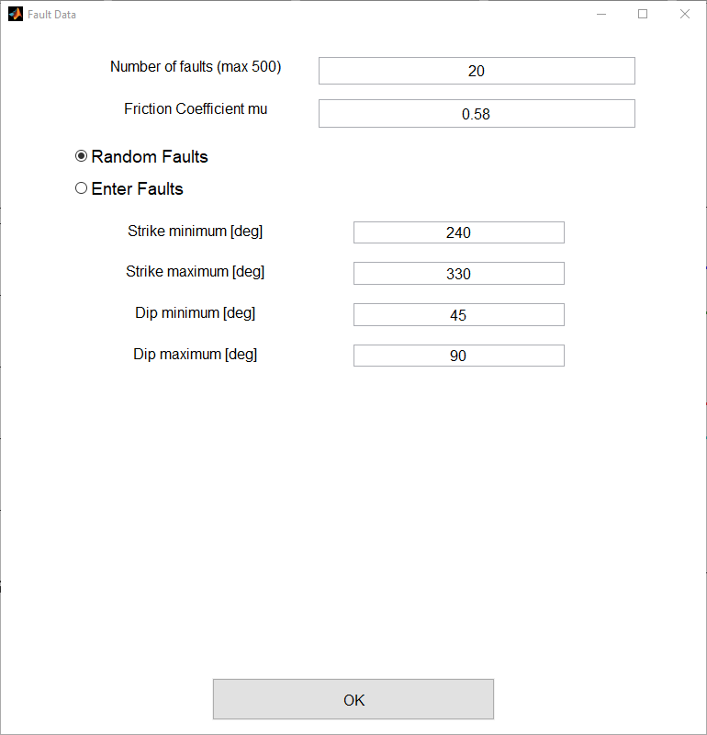 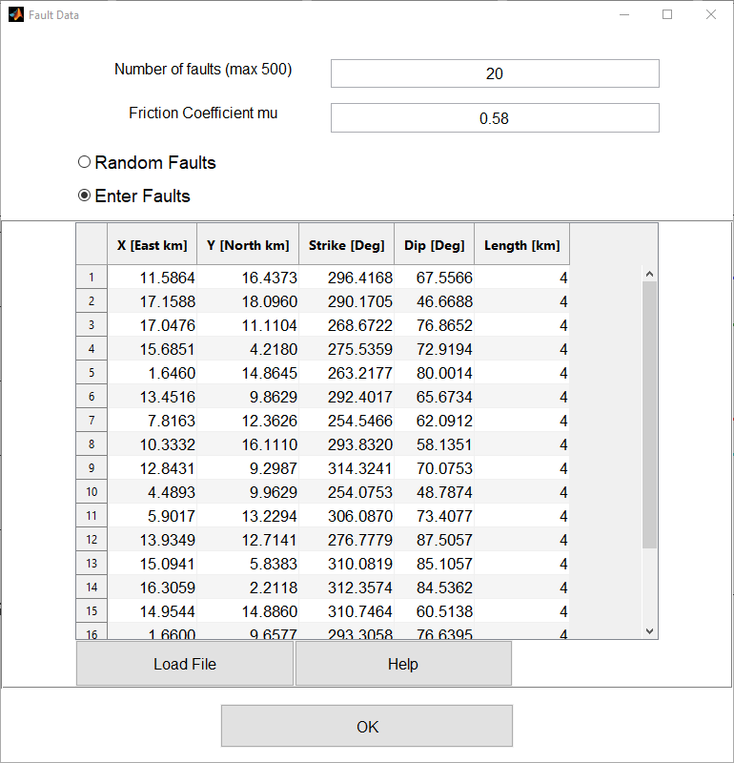

FSP can assess up to 500 faults produced by either entry method. If more than 500 faults need be analyzed in one model, see Advanced Startup Specifications below.

Faults are treated with the following simplifying assumptions: (1) that the fault will be geomechanically analyzed at the reference depth of the stress calculations, (2) that the fault has a constant planar orientation (though uncertainties in strike and dip can be entered in the “probabilistic geomechanics” panel), (3) that the fault does not influence the permeability structure, and (4) that the fault will slip under Mohr-Coulomb criteria without perturbing the surrounding stress or permeability fields. Potential dynamic rupture or static stress transfer triggering effects are not assessed. Other than through uncertainty in fault orientation, FSP doesn’t treat fault roughness on a scale smaller than that of the plane entered. Similarly, other than the stress uncertainties entered, small-scale stress heterogeneity is not explicitly addressed.

### Advanced Parameters

In the advanced menu, the northing and easting bounds of the mapped domain can be edited (though the hydrologic model assumes that the injection formation is laterally unbounded). In addition, fluid density, dynamic viscosity, fluid compressibility, and rock compressibility can be specified here. If a seed (a positive integer) is set, the pseudorandom faults and parameters generated will be identical each time the calculate button is pressed. If the seed value is zero, the program will generate a seed based on the computer clock, resulting in a different set of random faults each time the calculate button is pressed.

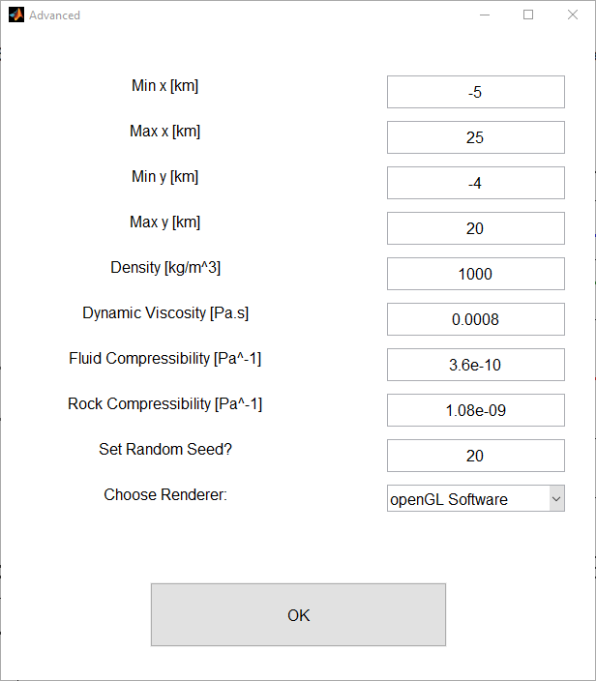

The “choose renderer” option is a patch for a known bug where certain MATLAB renderers are incompatible with certain graphics cards. The symptom of this is that all plots still work, but all letters are shown upside down and backwards. If this effect is observed, selecting a different renderer from the dropdown menu may fix the incompatibility. If the bug is not observed, the menu need not be touched. This is also the renderer that will be used to export images with the “Export Images” dropdown menu below.

Once all data above have been entered, press the 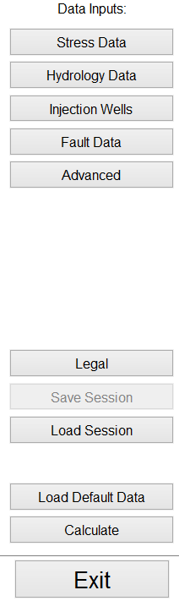button, which tells FSP to analyze the data and allows the operator to move on to the next tab. Results should be manually recalculated any time new data are loaded or entered. The button turns red if inputs have been changed and recalculation is required.

#### Advanced Startup Specifications

For more advanced users, there are 4 parameters that can be specified on program startup by including a text file named: FSPStartupSpecifications.txt in the same directory as the FaultSlipPotential_1.0.exe file. These parameters are (1) the maximum number of wells the program can take (default is 100), (2) the maximum number of faults the program can take (default is 500), (3) the radius of the dots plotted on the Mohr Diagrams and stereonet for each fault (default is 10), and (4) the RGB triplet from 0 to 1 of the grey axis backgrounds (default is [.8, .8, .8]). Below are example lines that can be specified in the text file with the relevant number edited as desired.

hDV.data.nwells_max=150; % 100 is default Max well count

hDV.data.NFAULTSMAX=600; % 500 is default Max Fault count

hDV.colors.axsBgrnd=[.4,.4,.4]; % [.8,.8,.8] is default RGB axis background color

hDV.plotdata.mohrCircleDotSize=4; % 10 is default dot size

If FSP sees a file named FSPStartupSpecifications.txt in the same directory as the .exe at startup, it will take any or all of these four specifications, otherwise it will use defaults. Note that if a model with more than the default maximum is saved and reopened, the same startup file will be needed for the new session, and also that computation and startup time will increase proportionally.

## Exporting High Resolution Images Menu

The export image menu allows the export of images produced in each tab at high resolution. The resolution can be specified between 150 and 1200 dots per inch under “Change Export Image Settings”. Images can be exported in .jpg, .png, or .tif format. .eps format can also be attempted but is subject to poor vectorization and liable to run into MATLAB related bugs. It is best to have each image visible on screen when you select it for export. While the implementation of this feature is admittedly crude, all figures can also be captured as screenshots if necessary, and all curves can be exported as .csv files for plotting or analyzing externally.

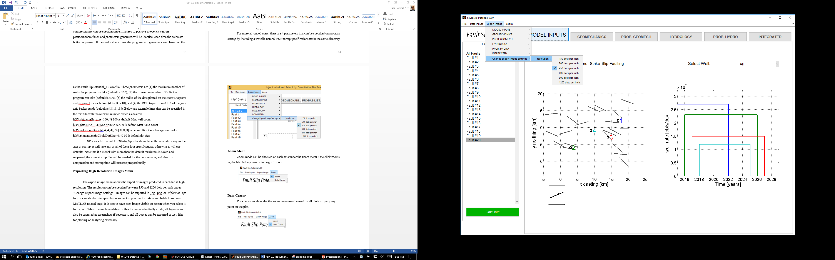

## Zoom Menu

Zoom mode can be checked on each axis under the zoom menu. One click zooms in, double clicking returns to original zoom.

. 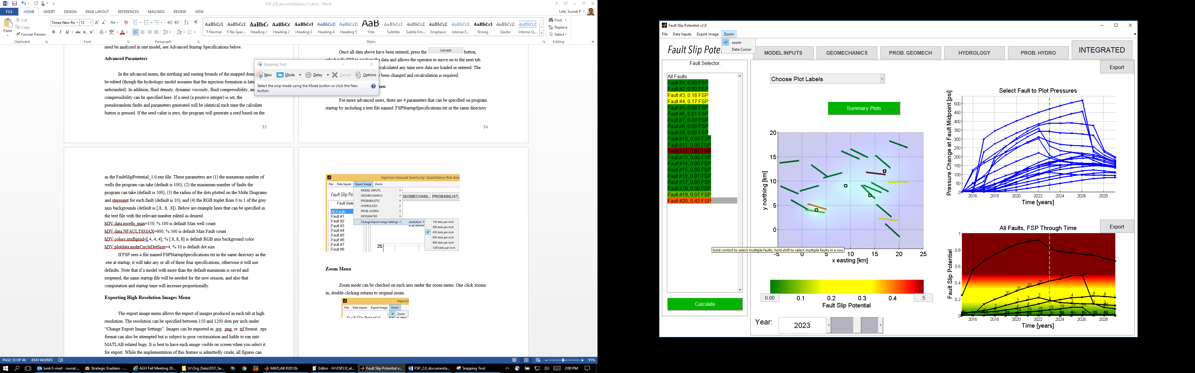

## Data Cursor

Data cursor mode under the zoom menu may be used on all plots to query any point on the plot.

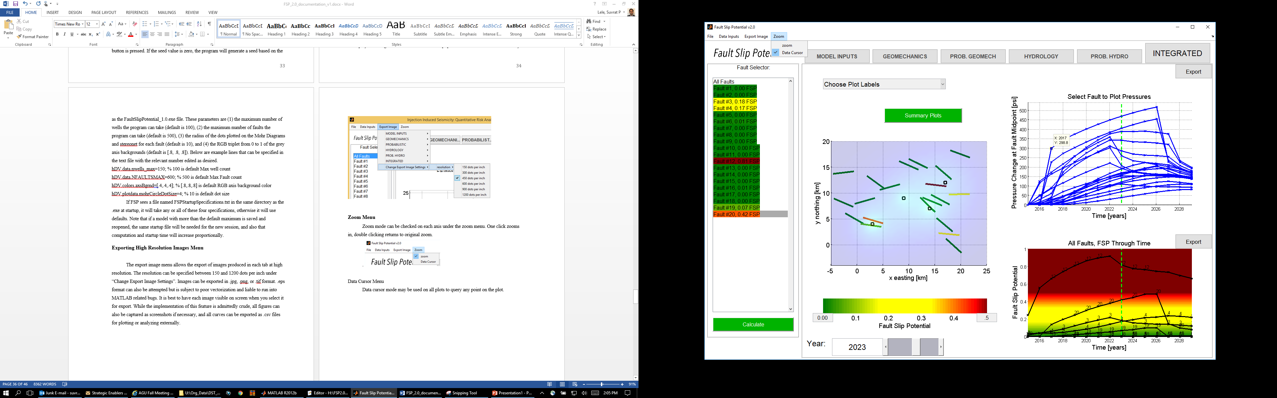

## Fault Selector Menu

The fault selector menu allows the selection of one or more faults for visualization purposes. The selection of faults does not influence model calculations. Multiple faults can be selected using control + clicking. Multiple faults in a row can be selected by holding shift + clicking the first and last faults. In certain plots, such as the tornado and generate input distribution plots, only one fault can be visualized at a time. In those cases, the first (lowest numbered) selected fault is displayed. Once faults have been generated, they will be colored based on the tab that is selected. In the Deterministic Geomechanics, Probabilistic Geomechanics and Hydrology Tabs, the faults are colored based on their deterministic pore pressure to slip using the color scale from the Geomechanics tab. In the Probabilistic Hydrology and Integrated tabs, each fault is labeled with its slip potential and colored using the color scale provided in the integrated tab.

# DISCUSSION

By combining the probability of a fault slipping as a function of pore pressure with a deterministic or probabilistic estimate of pore pressure, we can characterize the probability of fault slip. A major benefit of the probabilistic approach is that it allows us to propagate the uncertainties in the relevant information to the model output. Using this approach, decision-makers can make informed choices on how to proceed with injection operations. If a fault is screened as too high potential for slip, based on the operator’s tolerance, the operator might either choose not to inject, or to undertake more complex modeling to account for some of the potentially relevant but un-modeled phenomenon. Alternatively, the operator might also choose to gather more information in order to decrease input uncertainties. In addition, analyses could be extended to assess the potential consequences of induced fault slip outside of this model. Because FSP is a decision-making tool, it is designed to reflect the program operator’s incomplete understanding of the relevant parameters.

# PROGRAM INSTALLATION

FSP 2.0 requires a 64 bit Windows machine and the free installation of MATLAB Compiler Runtime (MCR) version 8.0 (corresponding to MATLAB version R2012b). The MCR installation file is included with the FSP download, but is also available for free from the Mathworks website, at: <https://www.mathworks.com/supportfiles/MCR_Runtime/R2012b/MCR_R2012b_win64_installer.exe>

Note that while FSP was written in MATLAB, it does **not** require MATLAB to be installed on the machine to use FSP. Once MCR is installed, double clicking FaultSlipPotential_2.0.exe opens FSP.

If you use FSP, there is a 4 question survey we’d appreciate you filling out at:

<https://docs.google.com/forms/d/e/1FAIpQLSeB6PmKEJClI-QgK3WLfgEMRxbeVDPmrbguTK9wmgZPjHBiHQ/viewform>

There you have the option to provide your email for notification of future updates.

# REFERENCES AND RELATED PAPERS

Chae, K.S., and Lee, J.W., 2015, Risk analysis and simulation for geologic storage of CO2, in Proceedings of the World Congress on Advances in Civil, Environmental, and Materials Research, Incheon, Korea, 25–29 August 2015, 20 p.

Chiaramonte, L., Zoback, M.D., Freidman, J., and Stamp, V., 2007, Seal integrity and feasibility of CO2 sequestration in the Teapot Dome EOR pilot: Geomechanical site characterization: Environmental Geology, v. 54, p. 1667–1675, doi: 10.1007/s00254-007-0948-7.

Ellsworth, W. (2013). Injection-Induced Earthquakes, Science, 341, DOI: 10.1126/science.1225942

Goertz-Allmann, B. P., S. J. Gibbons, V. Oye, R. Bauer, and R. Will, Characterization of induced seismicity patterns derived from internal structure in event clusters *Journal of Geophysical Research – Solid Earth*

Holland, A. (2011), Examination of Possibly Induced Seismicity from Hydraulic Fracturing in the Eola Field, Garvin County, Oklahoma. Oklahoma Geologic Survey Open File Report OF -1 2011

Hornbach, M. J. *et al.* (2015) Causal factors for seismicity near Azle, Texas. *Nature Communications* 6:6728 doi: 10.1038/ncomms7728

Hseih, Paul A., and John D. Bredehoeft (1981), A Reservoir Analysis of the Denver Earthquakes: A Case of Induced Seismicity *Journal Of Geophysical Research*, Vol. 86, NO. B2, pp. 903-920, February 10, 1981.

Hurd, O. and Zoback, M. D., (2012) Intraplate earthquakes, regional stress and fault mechanics in the Central and Eastern U.S. and Southeastern Canada. *Tectonophysics* 581 182–192.

Keranen, K.M., Savage, H.M., Abers, G.A., and Cochran, E.S., 2013, Potentially induced earthquakes in Oklahoma, USA: Links between wastewater injection and the 2011 Mw 5.7 earthquake sequence: Geology, v. 41, p. 699–702, doi:10.1130/G34045.1.

Lund Snee, J., Zoback, M. D. (2016) State of stress in Texas: Implications for induced seismicity *Geophysical Research Letters* : 7

Moos, D., Peska, P., Finkbeiner, T., and Zoback, M.D., 2003, Comprehensive wellbore stability analysis utilizing quantitative risk assessment: Journal of Petroleum Science Engineering, v. 38, p. 97–109, doi:10.1016/S0920-4105(03)00024-X.

National Research Council, 2013, Induced seismicity potential in energy technologies: Washington, DC: The National Academies Press, 262 p., doi:10.17226/13355.

Nygaard, K. J., J. Cardenas, P. P. Krishna, T. K. Ellison, and E. L. Templeton-Barrett (2013). Technical Considerations Associated with Risk Management of Potential Induced Seismicity in Injection Operations, ExxonMobil Production Company, http://www.gwpc.org/sites/default/files/event‑sessions/Nygaard_Kris.pdf (last accessed February 2017).

Walsh, F. R. and Zoback, M. D. (2016), Probabilistic assessment of potential fault slip related to injection-induced earthquakes: Application to north-central Oklahoma, USA. *Geology* v. 44 no. 12 p. 991-994 doi:10.1130/G38275.1

Walters, R. J., Mark D. Zoback, Jack W. Baker, Gregory C. Beroza (2015), Characterizing and Responding to Seismic Risk Associated with Earthquakes Potentially Triggered by Fluid Disposal and Hydraulic Fracturing. *Seismological Research Letters* Volume 86, Number 4 July/August 2015 1 doi: 10.1785/0220150048

Zoback, M. D., 2010 Reservoir Geomechanics, Cambridge University Press

Zoback , M. D., (2012), Managing the seismic risk posed by wastewater disposal, *Earth Magazine*, Apr. 17th. https://www.earthmagazine.org/article/managing-seismic-risk-posed-wastewater-disposal

# APPENDIX A: SELECTED SCREENSHOTS

